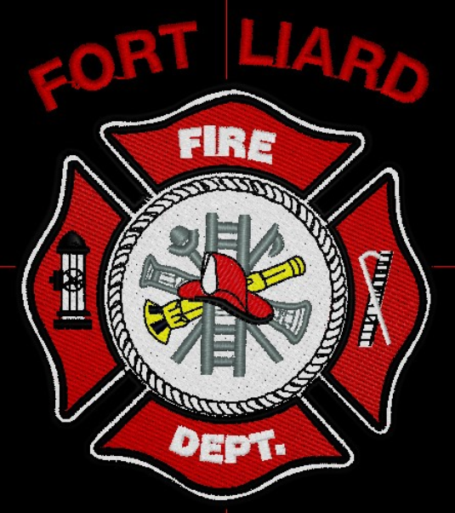
Current me mbers

Fire Chief – C. Evelyn Wilson
Start date: June 11, 2018

Assistant Fire Chief –
Kayly Deneron
Start date: November 1, 2018

Fire Fighters

Captain – Nathan Wilson
Start date: November 8, 2018

Arthur Loe
Start date: April 1, 2012

Ivy-Lynn Marcellais
Start date: October 18, 2018

Kali Norn
Start date: March 5, 2021

Travis Goodburn
Start date: May 11, 2022

Seymore Chambers (Rookie)
Start date: September 7, 2022

Ainsley Allen (Rookie)
Start date: January 18, 2023

Jade Ajibade (Rookie)
Start date: January 25, 2023

Ross Duntra (Gahcho Kué Mine) *will attend when in town.
Start date: August 19, 2020

Illonis Hall (Rookie)
Start date: September 7, 2022

  - february 2023

fire chief’s report
Fire Fighter Nathan Wilson has been Acting Fire Chief since August 2022, both him and Kayly Deneron have been such great help with stepping up and helping to be on call when needed. It has come to an agreement Kayly Deneron will be taking on the role of Assistant Fire Chief and Nathan Wilson – Captain. Congratulations to them both for stepping into their new roles.

For the month of February, we practiced Donning and Doffing our bunker gear with our newest recruits and for us too, obstacle / exercise in pairs, Truck inspections, Search and Rescue with the SCBA’s and re-arranged and tided Bay 1 and 2. In attendance, we put in 116-man hours together with Fire Practice alone.

The department wants to start a recruiting and retention program. To do this we would like to purchase uniforms for the current members. Wearing uniforms at public functions within the community and away on training will show professionalism of the department. We would also like to have t-shirts to give to our members along with issuing to new members.

The department purchased 3 SCBA’s last year and each SCBA came with one bottle to be effective as a department we should have a spare air cylinder for each SCBA pack. I will supply council with a quote price for these cylinders. Currently when the air packs are used at a call or for training, we must take the cylinders to get filled either Fort Nelson or Fort Simpson. Purchasing a breathing air compressor would make it more beneficial to filling the air cylinders.

To meet WSCC regulations our fire truck and air packs must be inspected and serviced annually, Rocky Mountain Phoenix, from Red Deer is the company that does fire departments in NWT. I will book them for next year when they are coming to the territory.

Back (Men) L-R Captain Nathan Wilson, Fire Fighters Arthur Loe, Travis Goodburn, Ainsley Allen, and Seymore Chambers
Front (Ladies) L-R – Fire Fighters Ivy-Lynn Marcellais, Kali Norn, Fire Chief C. Evelyn Wilson,
Fire Fighter Jade Ajibade and Assistant Fire Chief Kayly Deneron
Fire Practice – every Wednesday’s at 6:30pm
February 1, 2023
Seven members in total, AFC Kayly Deneron, Captain Nathan Wilson, Fire Fighters Kali Norn, Travis Goodburn, Seymore Chambers and Ainsley Allen and me, Fire Chief Wilson. This evening we practice Donning and Doffing our gear, after we set up an obstacle course and broke up in pairs for an exercise activity.
February 8, 2023
Seven (7) in attendance, AFC Deneron, Captain Wilson, Fire Fighters Loe, Goodburn, Chambers, Allen, Ajibade and me, Fire Chief Wilson. We split up in teams of three and did Truck Inspections and afterwards we got Loe and Chambers on SCBA to do a Search and Rescue.
February 15, 202
Nine (9) members in total, AFC Deneron, Captain Wilson, Fire Fighters Loe, Norn, Goodburn, Chambers, Allen, Ajibade and me, Fire Chief Wilson. Tonight, was the last night for two of our members Fire Fighters Norn and Goodburn. We tidied up Bay 2 fill station, changed the flood light bulbs on the Support Truck, ladder training and at the end of the night we thanked Kali and Travis for the time and commitment to the Fire Department. Our best endeavors to the both of them.
February 22, 2023
Six (6) members present, AFC Deneron, Fire Fighters Loe, Chambers, Allen, Ajibade and me, Fire Chief Wilson. We rearranged some of the equipment around the Fire Department.
PERMITS: | CALLS RECEIVED:
Burn Permits: NIL  Fire Works Permit: One (1) | Fire Emergency:  Non-Emergency: Two (2), 911 testing our number and no response

ISSUES / CONCERNS:
- All our PPE Gear are in need of replacement, due to oil residue and tears/rips.

- First Aid/ CPR, Chain Saw Course and Air Brakes

- Radios, everyone on the scene should have some sort of communication. They’ll be working in pairs for now but if they get separated for reason, there will be do communication.

- Flashlights are highly recommended.

- Spare MSA/ SCBA bottles or an upgrade on the fill station at the Fire Hall. Annual inspection for our MSA / SCBA equipment and Pumper Truck. Fire Departments use Rocky Mountain Phoenix.

