  - OCTOBER 2022

fire chief’s report
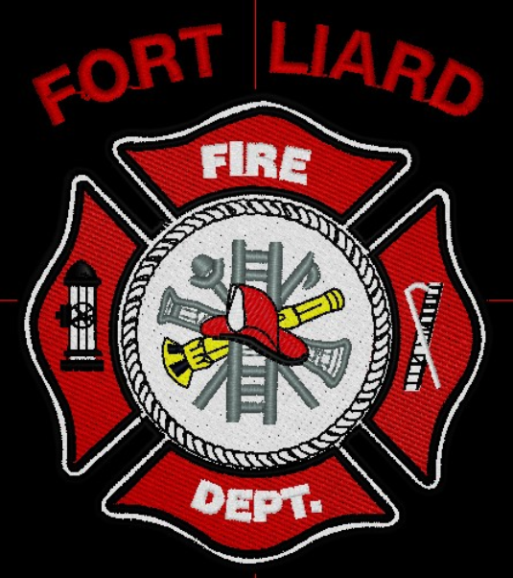
Current me mbers

Fire Chief – C. Evelyn Wilson
Start date: June 11, 2018

Assistant Fire Chief – Arthur Loe
Start date: April 1, 2012

Fire Fighters

Ivy-Lynn Marcellais
Start date: October 18, 2018

Kayly Deneron
Start date: November 1, 2018

Nathan Wilson
Start date: November 18, 2018

Ross Duntra (Gahcho Kué Mine) *will attend when in town
Start date: August 19, 2020

Kali Norn
Start date: March 5, 2021

Travis Goodburn (Rookie)
Start date: May 11, 2022

Seymore Chambers (Rookie)
Start date: September 7, 2022

Illonis Hall (Rookie)
Start date: September 7, 2022

October has been quite the busy month for the Fire Department especially for calls. The training we received in September from Fire Chief Adam McNab, sure paid off. The six of us that attended the training are all very confident/ comfortable feeling now as a Fire Department and as a team.

Oct 1st – RCMP called, pallet fire at the arbor and victim in distress– five on scene
OCT 6th – Bush fire - 0.7 hectares 12:45pm – 2:33am – Bulldozer, called EMO at 5:40pm – 9 in attendance at the end of night there was seven in total
Oct 7th – Bush fire – EFF Crew were there all afternoon and had ask from assistance, we went out 5:30pm – 1:30am, called in for Beaver’s Water Truck and got another call to Birch. Chimney / Fuel smell, 8:05pm – 9:33pm
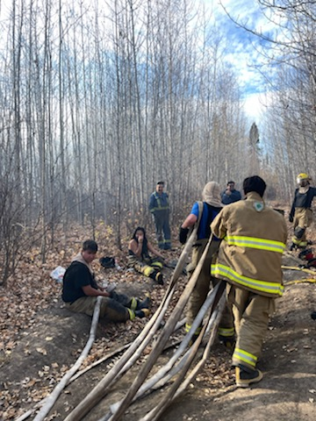
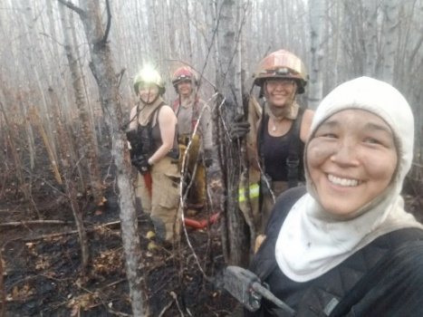

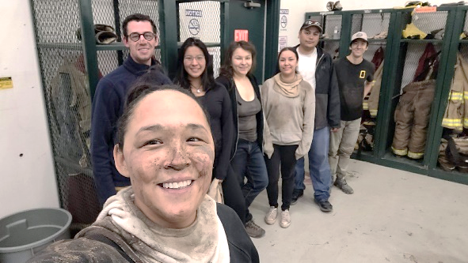

Fire Practice – every Wednesday’s at 6:30pm

October 5th, 2022
Five members in attendance, AFC Loe, Fire Fighters Deneron, Wilson and Goodburn and me, Fire Chief Wilson. We planned out Fire
October 12th, 2022
Three in attendance, they had washed majority of the 1 1/2” hoses and hung them up to dry.
October 19th, 2022
Three members – Cleaned Bay 1 and got everything ready for Fire Prevention.
October 23rd, 2022 – FIRE PREVENTION
Six of us from the Fire Dept came out and had a successful event. Fire Fighters Wilson, Norn, Goodburn, Chambers and Hall and me, Fire Chief Wilson. We had a good turnout. We would like to thank the following sponsors who made this a successful event: Hamlet of Fort Liard, Beaver Enterprises Ltd, Acho Dene Koe First Nation, Liard Fuel Centre, Liard Valley General Store, Northern Store and especially NWT Power Corporation. All gift cards were given out and signed by each winner.
PERMITS: | CALLS RECEIVED:
Burn Permits: NIL  Fire Works Permit: NIL | Fire Emergency: Four (4)  Oct 1, 2022 – Pallet Fire at Arbor & Victim in Distress  Oct 6 & 7, 2022– Bush/Brush fire Quad trail on Caragana/ Airport  Oct 7, 2022 – Chimney Sparks / Fuel Smell on Birch Street  Non-Emergency: Seven calls (no answer), One wrong number and two (2) calls about the Wildland fire at KM78
ISSUES / CONCERNS:
- Five (5) Fire Fighters need to replace their Bunker Gear jackets due to tears or oil residue on them. They are to be destroyed. Our PPE gear will need to be replaced soon.

- First Aid/ CPR, Chain Saw Course and Air Brakes

- Radios, everyone on the scene should have some sort of communication. They’ll be working in pairs for now but if they get separated for reason, there will be do communication.

- Flashlights are highly recommended

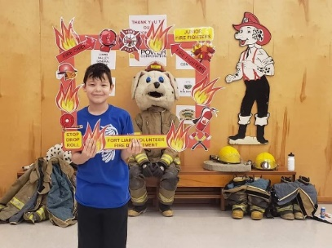
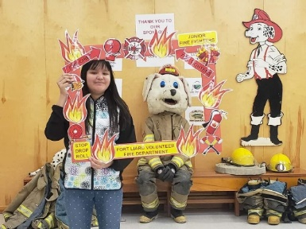
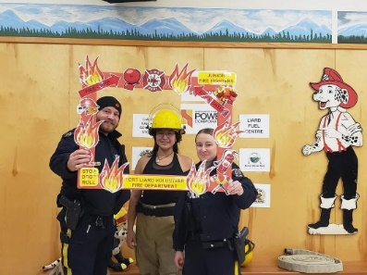
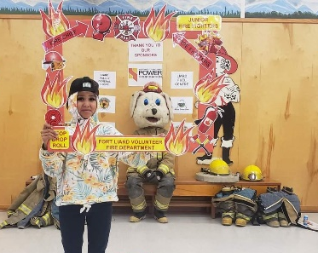
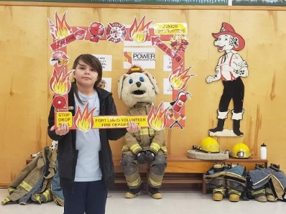
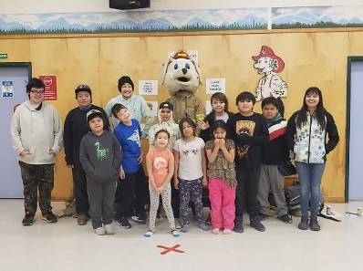
Thank you to the following sponsors

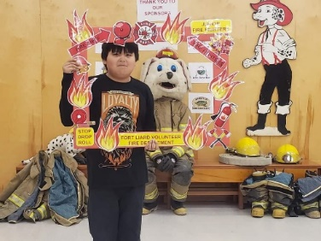
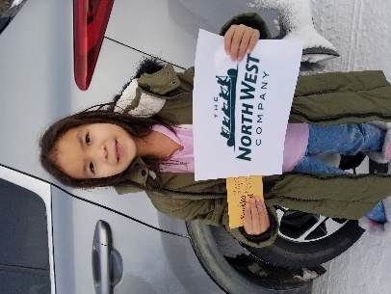
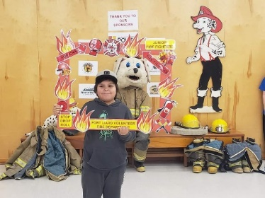
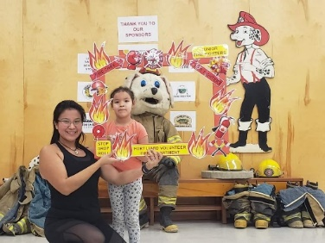
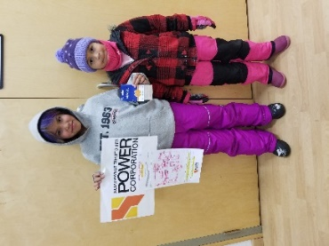
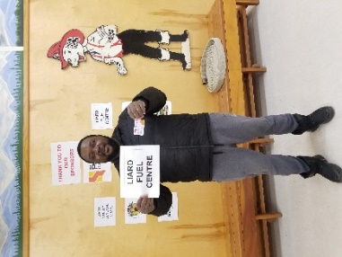
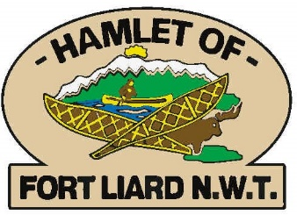
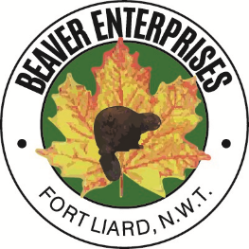
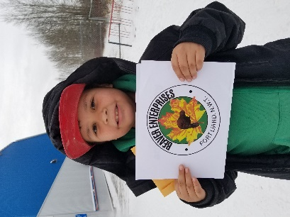
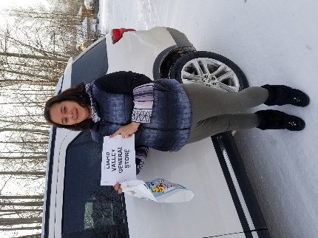
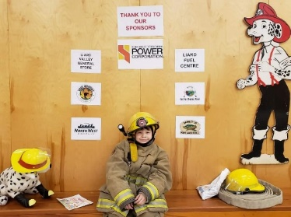
LIARD VALLEY GENERAL STORE
LIARD
FUEL
CENTRE

