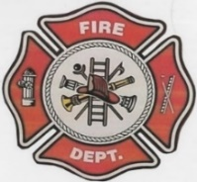 | Fire Chief’s Report  May 2022
Fire Chief – C. Evelyn Wilson  Start date: June 11, 2018  Assistant Fire Chief – Arthur Loe  Start date: April 1, 2012  Fire Fighters  Ivy-Lynn Marcellais  Start date: October 18, 2018  Kayly Deneron  Start date: November 1, 2018  Nathan Wilson  Start date: November 18, 2018  Bailey Weber (Moving)  Start date: May 13, 2020  Ross Duntra (Gahcho Kué Mine) **will attend when in town**  Start date: August 19, 2020  Kali Norn  Start date: March 5, 2021  Travis Goodburn  Start date: May 11, 2022  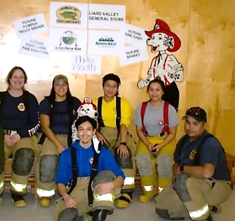 | As we are sad to see another Fire Fighter leave, we would like to say Thank you to Bailey Weber for her time she spent with the Fire Dept. Best endeavors to her in Hay River. Also, we’d like to welcome Travis Goodburn whom recently moved here to Fort Liard and expressed interest in joining the Fire Department. He attended his first practice May 11, 2022.  NWT Fire Chief’s Conference is set for June 8th to the 13th in Yellowknife, NT. Accommodations are to be booked as soon as possible. Wednesday is meet and greet, Thursday is MACA and AGM, Friday & Saturday is Fire Command and Sunday is TBA and Banquet. The invite was forwarded to our SAO April 4th, 2022.  A part of the Executive board of directors are as follows: Travis Wright – President, Roger Pilling – Vice President, Gerda Groothuizen – Treasurer, C. Evelyn Wilson – Secretary, North Representative Cyndy Hammond.  Due to a series of unforeseen event including the flooding in Hay River the Executive of the NWTFCA had decided to put the 2022 learning symposium postponed until 2023.
Fire Practice – every Wednesday’s at 6:30pm
May 4th, 2022
CANCELLED PRATICE (I wasn’t feeling well)

May 11th, 2022
Four members in attendance with one of our members helping with Flood watch. Fire Fighters Deneron, Marcellais, Goodburn and myself, Fire Chief Wilson. We went and topped off the Pumper and Support truck with fuel then took a ride through town. Our newest recruit Travis Goodburn came out.

May 18th, 2022
Six members present Assistant Fire Chief Loe, Fire Fighters Wilson, Deneron, Marcellais, Norn, Goodburn and me, Fire Chief Wilson – we washed both the Pumper and Support trucks and swept out both Bays 1 & 2.

May 25th, 2022
Four members present Assistant Fire Chief Loe, Fire Fighters Deneron and Goodburn along with me, Fire Chief Wilson. Last night we set up an obstacle course outside the Fire Hall. Obstacle courses consist of Hose carrying/ running up the Hamlet chairs and down the ramp, drag our Dummy Fred from the end of the ramp to Fire Hall, five tire flips, twenty arm battles with our old hose, hopscotch and at the end all together do five jumping jacks.

Page 1

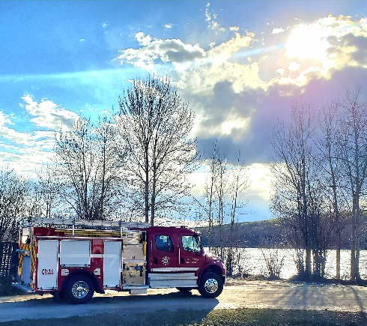
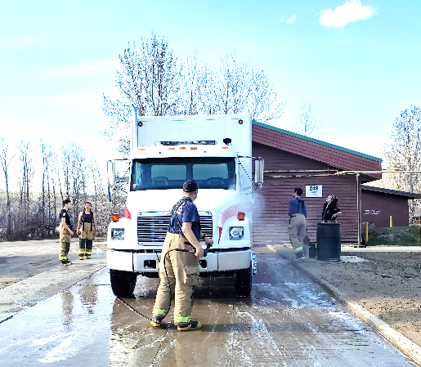
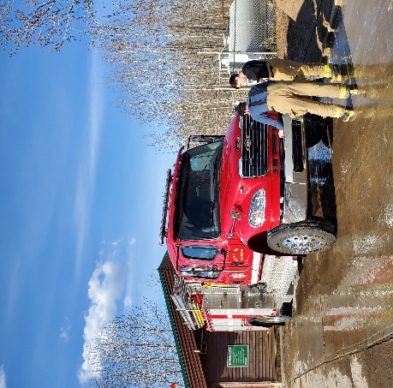

ISSUES / CONCERNS:
Five (5) Fire Fighters need to replace their Bunker Gear jackets due to tears or oil residue on them. They are to be destroyed. Our PPE gear will need to be replaced soon.
At this moment, trying to recruit new members has been very challenging. I have it advertised on the Website and the Screen outside the fire hall. I’ve reached out to the ENR off season crew, a few applications have been picked up but there has been no interest shown. If any community members have any suggestions on how to recruit new members, please share your ideas. With Fire season coming near, it would be good to have more members available.
Permits: |  | Calls Received:
Burn Permits: Two (2)  Fire Works Permits: 0 |  | Fire Emergency: NIL  Non-Emergency: Three (3) unknow (no response), one for RCMP, multiple calls during water rising through town, and from NTPC in Fort Simpson.
 |  |  | Page 2

