Fire Chief Monthly Report for June 2020

June has been great for attendance during Fire Practices but other than that it was a quiet month.

We got our first propane leak call, quick response, everything was controlled well and managed to get it shut off over at the Grocery Store Managers house. This was Bison related.

Fires: (0) and Propane Leak (1)

June 27, 2020 at 12pm Dustin Hope, Water Truck driver called me over the radio and said that there was a propane tank at the Grocery Store managers residence was tipped over and was leaking propane. Greg and I went over and checked it out. He went and told Melissa to evacuate immediately.

I called Arthur on the radio and he was ready at the Fire hall then I sent out the group text FIRE, FIRE, FIRE to our group at 12:08pm.

On scene was Arthur on Pumper Truck, then Vincent with Support truck. Nathan got on the radio and couldn’t get the Water truck out of the Bay. I ran from the Community Hall toward the Fire Hall and as I got closer, he got the Water truck out. I rode back with him to the Community Hall. On scene was me, Deputy Fire Chief Arthur Loe, Nathan Wilson, William Sassie, Jeremy Punch, Vincent Bertrand and afterwards Bailey Weber showed up.

I had parked the Fire Chief Truck in the Rec Centre parking lot along with the Pumper Truck, Water Truck was parked on the side of the road as you go in the rec centre parking lot and the support truck by the Craft shop. We left our radios and cell phones behind the Pumper truck as I didn’t want static to ignite an explosion. I had Nathan, William and Jeremy tape off all entries by the Northern warehouses and as well the Daycare entry. I had Vincent on crowd control, Jeremy and William on Pumper truck.

Talking with Kelly from Superior Propane, he suggested that I send in a crew to shut off the propane tank. Nathan and Arthur immediately stepped up, put on their Scott air packs (SCBA), went in low and slowly with a hose toward the tank. Between Jeremy and William, they both said that they can run the Pumper truck. As Arthur and Nathan got closer to the tank, both Jeremy and William couldn’t work the pumper truck controls. I had to call in Vincent to switch with Jeremy. During this whole time, there was a lot of yelling as we didn’t have no radios or cell phones on scene. Once Vincent got to the Pumper truck, he had the hose line going for both Arthur and Nathan to go to the tank to shut it off. They slowly went back to the tank and managed to shut it off. Nathan, William and I got permission to go into the Northern staff house to check to see if there was any odor inside as well as to open up the windows.

After they shut off the valve on the propane tank, we wrapped up and had a debrief at the site and went back to the Fire Hall. We hung out at the Fire Hall for a bit. I did advise Greg Wilson the Manger of the Northern store not to let Melissa back home for the night as the propane odor was still strong outside. With the grass being long out in the back of the house and between the arbor, the odor lingered a little longer.

Later, that evening we went back to the site and watered down that whole grassy area outside the Northern staff house where the propane had leaked. On scene then was Kayly Deneron, Vincent Bertrand, Arthur Loe, Bailey Weber, Nathan Wilson and me.

I met with Kelly from Superior Propane the following day and he mentioned that we did a great job.

Being our first propane leak, we as a team handled this call very well. It got my adrenaline going as well as everyone else on the team. I want to say “Hats off” to Nathan and Arthur for stepping up to shut off the valve. I know they were both aware of the situation but same time they took the risk and did a darn good job. I am proud to have them both apart of my team. We had heard a lone bison had rammed the Propane tank and knocked it over causing the propane leak.

Fire Practice: Every Wednesday evenings we meet at 6:30pm.

June 3, 2020 – Six (6) members in total. In present was Deputy Fire Chief Arthur Loe, Vincent Bertrand, Kayly Deneron, Nathan Wilson, Jeremy Punch and me. Did some hose training out at the cold shed on Bypass road and once done, we drove the trucks through town.

June 10, 2020 – Eight (8) members in attendance, me, Deputy Fire Chief Arthur Loe, Vincent Bertrand, Collin Woehl, Kayly Deneron, Nathan Wilson, Bailey Weber and Jeremy Punch. We brought birthday cake over to our fellow Fire Fighter Vanessa Villeneuve who cannot attend as her foot was broken. Afterward we went to Hay Lake and hose more hose training. This time we timed how long it took to empty the Pumper truck tank and how long to fill it from the water truck.

June 17, 2020 – Eight (8) members present, me, Deputy Fire Chief Arthur Loe, Vincent Bertrand, Collin Woehl, Kayly Deneron, Nathan Wilson, Bailey Weber and Jeremy Punch. This evening we went to the Skate Park and hosed down all the ramps and the park itself. I assigned Bailey Weber to work along with Arthur on the Pumper truck, he was teaching her how to work the controls. During this time, we had some kids out watching along with their parents, so we sprinkle some water on them. The excitement of each of the kids was priceless.

June 24, 2020 – Six (6) present, Deputy Fire Chief Arthur Loe, Collin Woehl, Kayly Deneron, Nathan Wilson, Bailey Weber and me. That evening we cleaned the Fire Hall and as well started peeling the stickers off the Backup Water Truck.

Active Members to Date:
Evelyn Wilson William Sassie Jeremy Punch
Arthur Loe Collin Woehl
Nathan Wilson Kayly Deneron
Bailey Weber Vincent Bertrand

Ivy-Lynn Marcellais (currently on Mat Leave)
Vanessa Villeneuve (broken foot, off for the next 6-8 weeks)

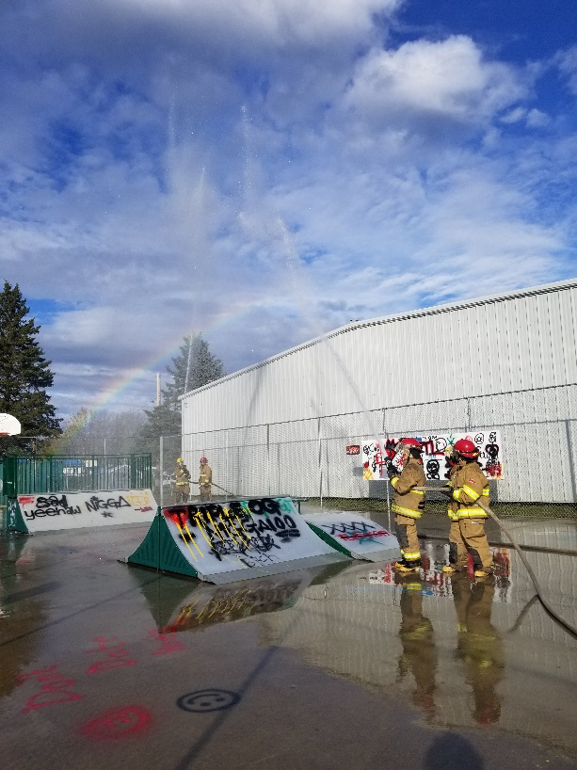
Issues: nil

Phone calls:
Fire Emergency – 1 Propane Leak
Google – 7 calls
Unknown (no answer) – 11 calls

