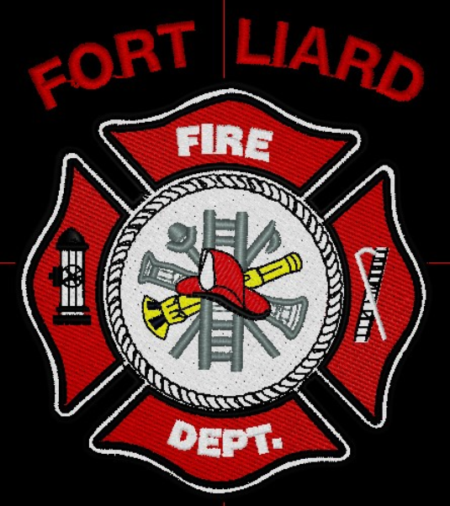
Current me mbers

Fire Chief
C. Evelyn Wilson
Start date: June 11, 2018

Assistant Fire Chief
Kayly Deneron
Start date: November 1, 2018

Fire Fighters

Captain – Nathan Wilson
Start date: November 18, 2018

Arthur Loe
Start date: April 1, 2012

Ivy-Lynn Marcellais
Start date: October 18, 2018

Seymore Chambers (Rookie)
Start date: September 7, 2022

Ainsley Allen (Rookie)
Start date: January 18, 2023

Jade Ajibade (Rookie)
Start date: January 25, 2023
  - MARCH 2023

fire chief’s report

First Aid Courses, Chain Saw Courses and Air Brakes are needed for our Fire Dept. This was brought up again during one of our practices.

They would also like to practice on vehicle fires or event something to burn for practice, but I did mention that we need a designated area to do something like this. The gravel pit was brought up but then again, I let them know that we don’t have a key to get into the area. They are thriving for more practice for team building/ communication.

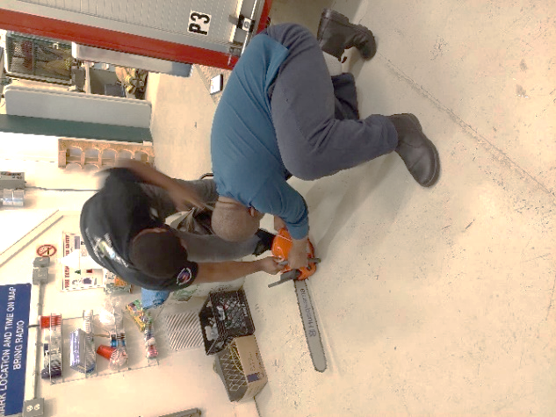
Fire FIGHTERS’ CHAMBERS & ALLEN TESTING THE CHAINSAW

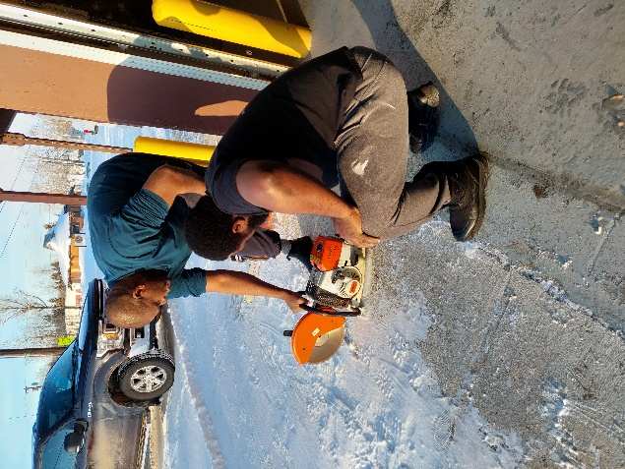

Fire FIGHTERS’ CHAMBERS & ALLEN TESTING THE ROOF SAW, DURING OUR INSPECTION CHECKS
Fire Practice – every Wednesday’s at 6:30pm
March 1, 2023
Six in attendance – AFC Deneron, Fire Fighters Loe, Chambers, Allen, Ajibade and me, Fire Chief Wilson. Hose training at Hay Lake and fuel up all three apparatuses.
March 8, 2023
Six members AFC Deneron, Fire Fighters Loe, Marcellais, Chambers, Allen, and me, Fire Chief Wilson. Last night we topped off our foam for the Pumper Truck and we properly laid out our hoses on the Pumper Truck.
March 15, 2023
Four in attendance, AFC Deneron, Fire Fighters Chambers and Allen and I, Fire Chief Wilson. This evening we took out the Chainsaw and the Concrete Saw, community drive.
March 22, 2023
Three of us in attendance, Fire Fighters Loe and Wilson and me, Fire Chief Wilson. This evening we moved all the bigger items from Pumper 1 to lower compartments.
March 29, 2023
Five in attendance, Fire Fighters Loe, Wilson, Marcellais, Chambers and me, Fire Chief Wilson. This evening we got asked by the ADKFN Band Office to judge the Snow Sculptures for Cabin Fever Days. Instead of looking through the photos they provided, we went to each of the homes to check them out for ourselves. Afterward, we went back to the Fire Hall to talk about the Pan Cake Breakfast for Cabin Fever Days.

PERMITS: | CALLS RECEIVED:
Burn Permits: nil  Fire Works Permit: nil | Fire Emergency: nil  Non-Emergency: nil
ISSUES / CONCERNS:
- All our PPE Gear are in need of replacement, due to oil residue and tears/rips.

- First Aid/ CPR, Chain Saw Course and Air Brakes

- Radios, everyone on the scene should have some sort of communication. They’ll be working in pairs for now but if they get separated for reason, there will be do communication.

- Flashlights are highly recommended.

- Spare MSA/ SCBA bottles or an upgrade on the fill station at the Fire Hall.

