  - SEPTEMBER 2022

fire chief’s report
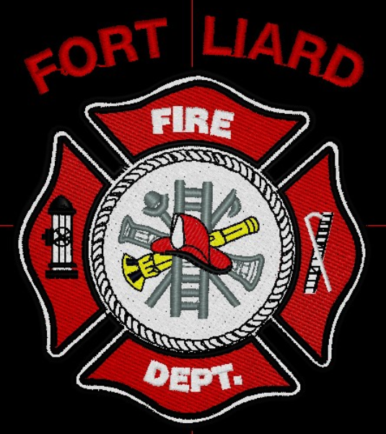
Current me mbers

Fire Chief – C. Evelyn Wilson
Start date: June 11, 2018

Assistant Fire Chief – Arthur Loe
Start date: April 1, 2012

Fire Fighters

Ivy-Lynn Marcellais
Start date: October 18, 2018

Kayly Deneron
Start date: November 1, 2018

Nathan Wilson
Start date: November 18, 2018

Ross Duntra (Gahcho Kué Mine) *will attend when in town
Start date: August 19, 2020

Kali Norn
Start date: March 5, 2021

Travis Goodburn (Rookie)
Start date: May 11, 2022

Lyle Bertrand (Rookie)
Start date: July 13, 2022

Seymore Chambers (Rookie)
Start date: September 7, 2022

Illonis Hall (Rookie)
Start date: September 7, 2022

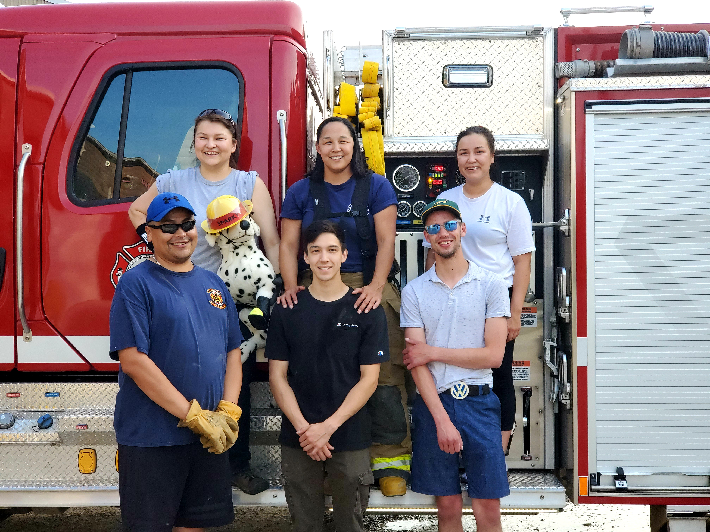

Adam McNab, Fire/ EMS Chief of Fort Smith came into Fort Liard to instruct Exterior Fire Fighter Basic course September 16th – 18th weekend and as well September 23rd – 25th weekend.
Skill training included: Fire Fighter Safety, Fire Service Communication, Establishing and Transferring Command, Donning/ Doffing PPE gear, Portable Fire Extinguishers, Fire Rehabilitation, Water Supply System, Intro Pump Operation, Supply Line and Attack Line Evaluation and Fire Suppression.
Six of us members completed the two weekends of training:
Evelyn Wilson Kali Norn
Kayly Deneron Travis Goodburn
Nathan Wilson Illonis Hall

The Fort Liard Volunteer Fire Department would like to say a big Thank you to the School of Community Government and along with Adam for this opportunity. Such a great learning experience for not only for Fire Fighters but for myself as well.
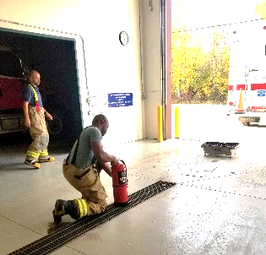
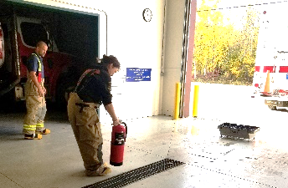
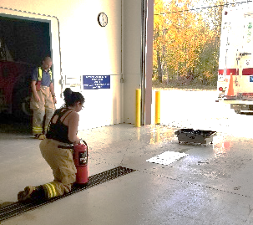
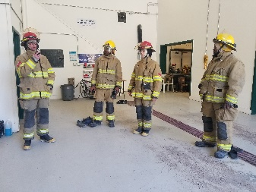
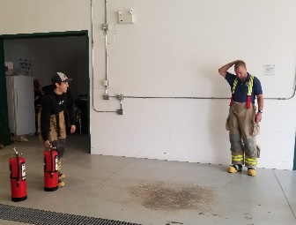

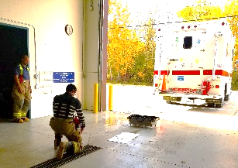
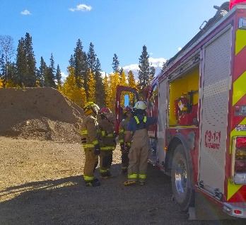

PERMITS: | CALLS RECEIVED:
Burn Permits: NIL  Fire Works Permit: NIL | Fire Emergency:  Non-Emergency: Two (2) separate call outs – one Improper use of fire works and second one at the Health Centre, alarm going off (false alarm).

Fire Practice – every Wednesday’s at 6:30pm

September 7th, 2022
Six members available, AFC Loe, Fire Fighters Marcellais, Wilson, Goodburn and myself, Fire Chief Wilson. We welcomed our newest recruits Illonis Hall and Seymore Chambers to our Fire Dept. We gave them a tour of the Fire Hall, all three apparatus’s and we have and set them up with PPE gear.
September 14th, 2022
Six members present, Fire Fighters Deneron, Wilson, Goodburn, Chambers, Hall and me, Fire Chief Wilson. This evening we took the Pumper and Support Truck. We did some hose and pumper operator training with the new recruits. As well, getting our newest recruit FF Chambers familiarized with the Support Truck. He brings in two years of experience from Behchoko Fire Dept.
September 21st, 2022
Three present, Fire Fighters Norn, Goodman and me, Fire Chief Wilson. We took the trucks out of the bay and cleaned out the Fire Hall.
September 28th, 2022
Five of us in attendance, Fire Fighters Deneron, Wilson, Norn, Goodburn and me, Fire Chief Wilson. This evening the Assistant Fire Marshal was present. We laid out and added new 1 ½” hoses to the Pumper truck and hung up the others to dry. We tried adding the new 2 ½” hoses on top of Pumper 1 but the fitting from the hose to the truck was not compatible so we put the old hoses back on for now until we come up with a solution. We went through and removed all the old SCOTT air pack bottles and emptied them out before getting disposed of.

ISSUES / CONCERNS:
- Five (5) Fire Fighters need to replace their Bunker Gear jackets due to tears or oil residue on them. They are to be destroyed. Our PPE gear will need to be replaced soon.

- First Aid/ CPR, Chain Saw and Air Brakes course for our Fire Dept.

- Radios, everyone on the scene should have some sort of communication. They’ll be working in pairs for now but if they get separated for reason, there will be no communication.

- Flashlights for each Fire Fighters are highly recommended especially for nighttime calls.

