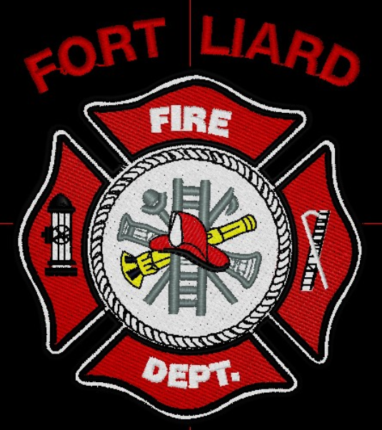
Current me mbers

Fire Chief – C. Evelyn Wilson
Start date: June 11, 2018

Acting Assistant Fire Chief –
Nathan Wilson
Start date: November 18, 2018

Fire Fighters

Arthur Loe
Start date: April 1, 2012

Ivy-Lynn Marcellais
Start date: October 18, 2018

Kayly Deneron
Start date: November 1, 2018

Ross Duntra (Gahcho Kué Mine) *will attend when in town.
Start date: August 19, 2020

Kali Norn
Start date: March 5, 2021

Travis Goodburn
Start date: May 11, 2022

Seymore Chambers (Rookie)
Start date: September 7, 2022

Illonis Hall (Rookie)
Start date: September 7, 2022

Ainsley Allen (Rookie)
Start date: January 18, 2023

Jade Ajibade (Rookie)
Start date: January 25, 2023

  - jANUARY 2023

fire chief’s report
We received our Exterior Fire Fighting – Basic training certificates and I had asked our Mayor Genevieve McLeod to come and help present them during Fire Practice Thursday, January 12, 2023.
Fire Fighters Kayly Deneron, Nathan Wilson, Kali Norn, Travis Goodburn, Illonis Hall and me, Fire Chief C. Evelyn Wilson completed this training course instructed by Fire Chief / Instructor Adam McNab of Fort Smith. Thank you to the School of Community Government, and thank you Fire Chief McNab for this great learning opportunity for our Fire Dept.
We would like to welcome our newest Rookies Ainsley Allen and Jade Ajibade to our Fire Department. This brings us to twelve (12) members to date.
We had scheduled a Fire Drill at the school January 19, 2023. Four of us in attendance.
Gas Field came in from Fort Nelson to inspect all the Fire Extinguishers, he left with a little over twenty (20) extinguishers to get recharged and serviced. They will contact the Hamlet office when their all completed.
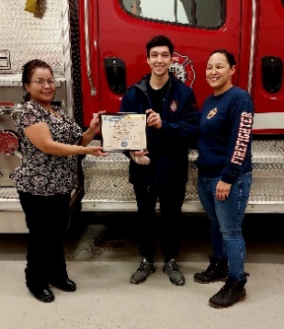
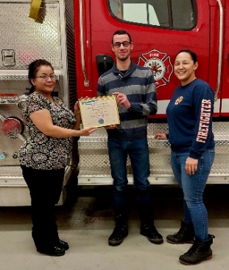
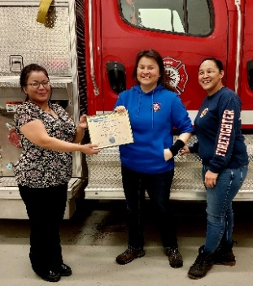
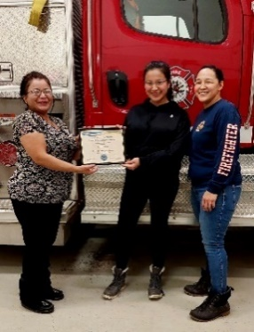

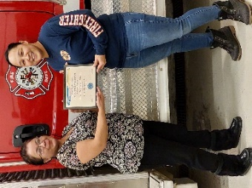
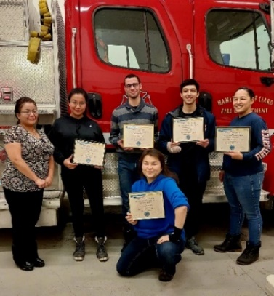

Fire Practice – every Wednesday’s at 6:30pm
January 4, 2023
Three of us in attendance, Fire Fighters Arthur Loe and Kali Norn and me, Fire Chief Wilson. This evening we took down all the Christmas decorations, tidied up and took all three vehicles out for a drive.
January 12, 2023
Practice was moved to the Thursday evening as the Christmas concert was set for Wednesday.
Seven of us members present, Fire Fighters Arthur Loe, Kayly Deneron, Nathan Wilson, Kali Norn, Travis Goodburn, Seymore Chambers and me, Fire Chief Wilson. I had asked our Mayor Genevieve McLeod to attend Fire Practice with us to help assist me with handing out our Exterior Fire Fighting – Basic certificates to the six of us who completed the training this past fall.
The six who completed the training are as follows: Fire Chief – C. Evelyn Wilson, Fire Fighters Kayly Deneron, Nathan Wilson, Kali Norn, Travis Goodburn and Illonis Hall. Thank you and congratulations.
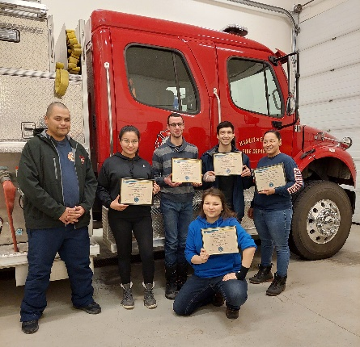
January 18, 2023
Five of us members, Fire Fighters Arthur Loe, Kayly Deneron and Seymore Chambers, our newest recruit “Rookie” Ainsley Allen and me, Fire Chief Evelyn Wilson. We got Ainsley hooked up with PPE gear, except for boots. He is a size 14 and the biggest pair we have are 13’s.
We removed all three apparatus’s out of the bays and laid out orange tuck tape on the floor to use guide when backing the trucks into the Hall, afterward, we went for a community drive and back to the Fire Hall.
January 25, 2023
Seven in total, Fire Fighters Loe, Deneron, Goodburn, Chambers, Allen, another recruit “Rookie” Ajibade and me, Fire Chief Wilson. This evening we set up Jade with PPE gear. After we set her up with gear, we did a mock exercise at the Hamlet warehouse in Bypass road and practiced transferring Incident Command between the Fire Chief and Fire Fighter Deneron and another mock call over at the Water Treatment Plant. We topped up the water truck and called it a night.

ISSUES / CONCERNS:
- Five (5) Fire Fighters need to replace their Bunker Gear jackets due to tears or oil residue on them. They are to be destroyed. Our PPE gear will need to be replaced soon.

- First Aid/ CPR, Chain Saw Course and Air Brakes

- Radios, everyone on the scene should have some sort of communication. They’ll be working in pairs for now but if they get separated for reason, there will be do communication.

- Flashlights are highly recommended.

PERMITS: | CALLS RECEIVED:
Burn Permits: NIL  Fire Works Permit: NIL | Fire Emergency: Two (2)  Jan. 8 - Possible propane leak on Willow Road (FALSE ALARM)  Jan. 24 – Single vehicle accident – coming down Muskeg Hill  Non-Emergency: One (1)

Attached is a breakdown of how many hours each of the Fort Liard Volunteer Fire Fighters put into the department for 2022. Each of them has dedicated their time for Community events, training, Fire Practice as well as Emergency calls. Last year was our busiest with emergency calls. After the Basic Fire Fighter training, those who participated feel more confident as fire fighters.
Arthur  Loe | Nathan  Wilson | Kayly  Deneron | Ivy-Lynn  Marcellais | Ross  Duntra |  | Kali  Norn | Travis  Goodburn |  |  | Seymore  Chambers | Illonis  Hall |  |  | Evelyn  Wilson
29 | 34.5 | 26.5 | 19 | 15.5 | 19 |  |  | 30.5 | 0 |  | 9 |  |  |  | 38 | FIRE EMERGENCY  CALLS
0 | 42 | 35 | 0 | 0 | 42 |  |  | 42 | 21 |  | 42 |  |  |  | 42 | Fire Fighter  Training
12 | 12 | 12 | 12 | 12 | 12 |  |  | 0 | 0 |  | 0 |  |  |  | 12 | Covid/ Isolation
4 | 13.5 | 4 | 10 | 0 | 19.5 |  |  | 16 | 22.5 |  | 6 |  |  |  | 22.5 | Community Events  & Activities
24.5 | 24.5 | 24.5 | 24.5 | 24.5 | 24.5 |  |  | 14 | 10.5 |  | 10.5 |  |  |  | 24.5 | No Practice
73.5 | 31.5 | 80.5 | 63 | 10.5 | 52.5 |  |  | 63 | 24.5 |  | 3.5 |  |  |  | 108.5 | Wednesday Night  Fire Practice
143 | 158 | 182.5 | 128.5 | 62.5 | 169.5 |  |  | 165.5 | 78.5 |  | 71 |  |  |  | 247.5 | TOTAL AMOUNT  HOURS
I personally want to thank each of them for all their hard work, dedication they’ve put into the department. I am glad to have them beside me all the way.

