

**Fire Chief Monthly Report for July 2020**

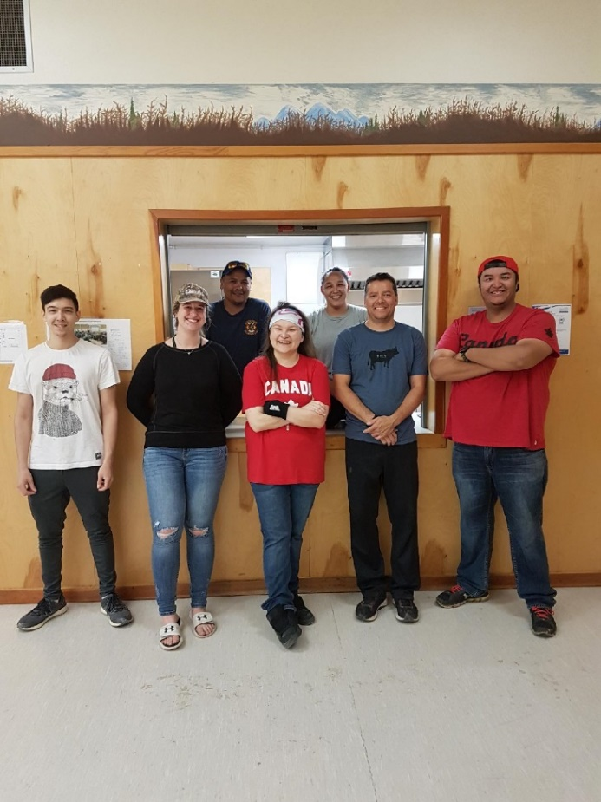The Fort Liard Volunteer Fire Department volunteered to cook for the Canada Day 2020 Pancake breakfast. Myself, Assistant Fire Chief Arthur Loe, Fire Fighters: Collin Woehl, Vincent Bertrand, Kayly Deneron, Nathan Wilson and Bailey Weber along with our Mayor Hillary Deneron.

I had Assistant Fire Chief Loe answer the radio for majority of the month of July as I was away on Annual.

***Fires: (1) and Propane Leak (1)***

**July 4th at 1:45pm**, a call came on the fire phone from a Security company about a smoke alarm was going off at 154 Birch Road. Falsa Alarm Call.

**(AFC Loe)**

**July 19, 2020 at 7:25pm** Assistant Fire Chief Loe called me on the radio and said there is a possible propane leak at the airport. I sent out the text **“Fire, Fire, Fire”, possible propane leak at the Airport** at 7:27pm. On scene were me, Assistant Fire Chief Loe Fire Fighters Nathan Wilson, Kayly Deneron, Collin Woehl and William Sassie.

When we arrived on scene, we could here the tanks whistling aloud. Two out of the three tanks were shooting out propane. All three roads to the Airport were already blocked off with the RCMP trucks. We immediately got that whole area evacuated.

Lance White and four others (unsure who they were) were standing out there as well. The moment we got there, Lance was trying to order us around and tell us what to do but I took control of the scene.

Arthur and Nathan went in afterward and found which tanks were leaking, they shut off both valves. We then all applauded Arthur and Nathan on a job well done. Talking with Constable Adam Betz, he said Lance had called him at 7:12pm that evening asking them for their assistance in blocking off roads. Constable Betz assumed that the Fire Department was called but I told him that it was Arthur that called me over the radio to let me know.

***Fire Practice:*** Every Wednesday evenings we meet at 6:30pm.

**July 1, 2020** – I cancelled practice that evening as the Fire Department volunteered to cook for the Canada Day 2020 Pancake breakfast & Canada Day Parade.

**July 8, 2020** – Assistant Fire Chief Loe, Nathan Wilson, Vincent Bertrand and Kayly Deneron were present. They took out the Pumper and Support truck and ran the pumps by the ball diamond, had Nate on the pumps then Kayly afterwards.

**July 15, 2020** – Assistant Fire Chief Loe, Nathan Wilson, Kayly Deneron and Collin Woehl were present. We reviewed the tools on the truck and went through the stages to engage the pumps with the truck off.

**July 22, 2020** – Assistant Fire Chief and Kayly Deneron were the only two that showed up that evening.

**July 29, 2020** – Assistant Fire Chief Loe, Nathan Wilson, Kayly Deneron and me were in attendance that evening. We had a quick brief update for the month, and we called it a night.

***Active Members to Date:***

Evelyn Wilson William Sassie Jeremy Punch

Arthur Loe Collin Woehl Vincent Bertrand

Nathan Wilson Kayly Deneron Bailey Weber

Ivy-Lynn Marcellais (currently on Mat Leave)

Vanessa Villeneuve (broken foot, off for the next 6-8 weeks)

***Issues:***

We have a couple Fire Fighters who do not attend Fire Practices but has showed up to the last couple calls. With their lack of knowing how to use the apparatuses, I did stress to them that they need to be present for practice so they can use them properly but for the month of July they both have not showed interest.

***Phone calls:***

**Fire Emergency** – 1 Fire call (False alarm) & 1 Propane Leak

**Google** – 7 calls

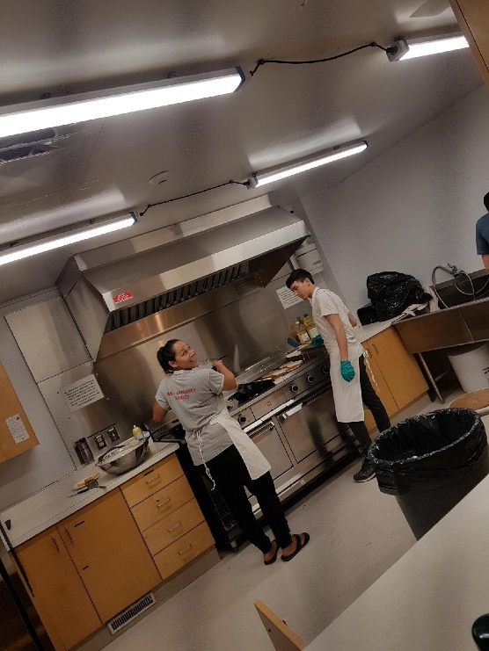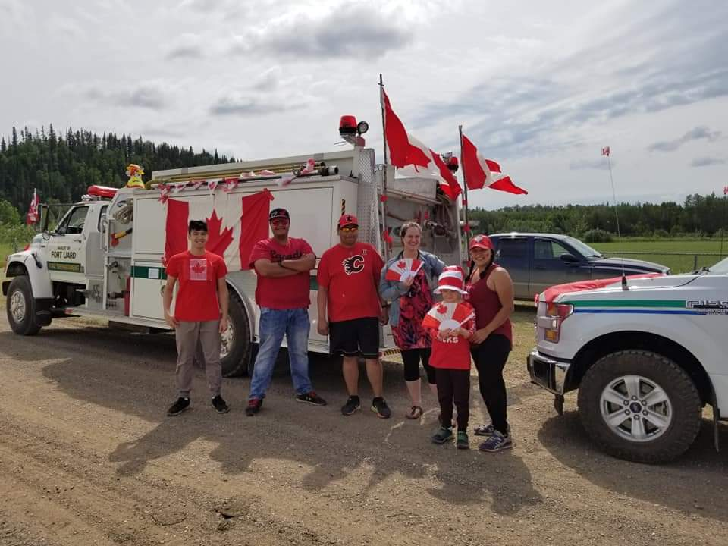**Unknown (no answer)** – 16 calls