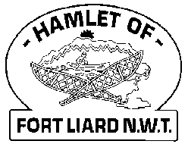
Fire Chief Monthly Report for October 2021

Fire Drill planned at the Echo Dene School Friday, October 15, 2021. AFC Arthur Loe, Fire Fighter Ross Duntra, Community Safety Officer Dylan Steeves assisted me at the school for the fire drill. Everyone exited the school in a very good time of under a minute. Everyone was accounted for; attendance sheets for each class were present. The staff and students were prepared for this one as it’s the first of the school year.
Fire Prevention activities were held Sunday, October 17, 2021, with six of us in attendance, AFC Arthur Loe, Fire Fighters, Nathan Wilson, Ivy-Lynn Marcellais, Bailey Weber, Kali Norn, and me Fire Chief Evelyn Wilson along with the Community Safety Officer Dylan Steeves.
We had six kids for the 6 & under for the Obstacle Course, nine kids for the 7-10 Obstacle Course, no youth for the 11-15 and eight for the 16 & over. We set up the course inside the Community Hall, Sparky made an appearance a couple times to say hi to the kids. Thank you to our Sponsors, Acho Dene Koe First Nation, Northern, General Store and Hamlet of Fort Liard.

Fire Practice: Every Wednesday evenings we meet at 6:30pm.
October 6th – Five (5) in attendance, AFC Arthur Loe, Fire Fighters Kayly Deneron, Nathan Wilson, Ivy-Lynn Marcellais, and me, Fire Chief Evelyn Wilson. We started planning for the Fire Prevention Week activities. After we were done that, we went and did a Fire Drill at the Youth Centre. They were prepared as they knew we were coming. We then drove through town and called it a night.
October 13th – Five (5) present, AFC Arthur Loe, Fire Fighters Ivy-Lyn Marcellais, Bailey Weber, Kali Norn and me, Fire Chief Evelyn Wilson. We put together 15 good bags for the 6 & under and over 20 bags for older kids. We got all the props ready for the obstacle course and stored into the Support Truck.
October 20th – No Practice because of Fire Prevention Activities held Sunday, Oct. 17, 2021
October 27th – Six members present, AFC Arthur Loe, Fire Fighters Collin Woehl, Kayly Deneron, Ivy-Lynn Marcellais, Kali Norn and me, Fire Chief Evelyn Wilson. We broke up in two teams of three and went to elder’s home up town to check to see if their smoke detectors are working or needed new one or batteries. Its an eye opener just to see how many elders’ home don’t have smoke detectors that don’t work or has been removed. We had seven detectors on hand, they’ve been all handed out. Next week, we’ll do downtown and that would be it for elder’s homes.

Fires:
Issues:
The Fire Dept could use more handheld radios, that way if an event of a real fire emergency, I would like to be in contact with all members. Right now, I have one, AFC Loe has one and we have three at the Fire Hall. I make sure that each driver has one before leaving the Fire Hall.
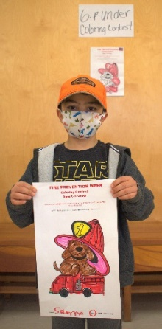
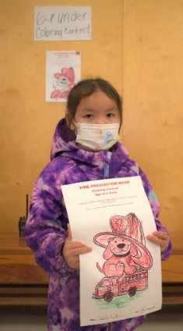
Five (5) Fire Fighters needed to replace their Bunker Gear jackets due to tears or oil residue on them. They are to be destroyed. Our PPE gear will need to be replaced soon.
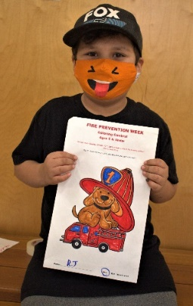
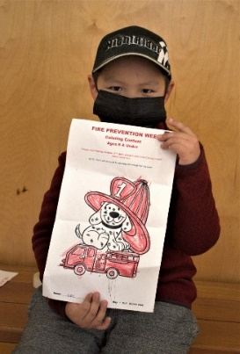
PERMITS
Fire Works Permits:
Three (3)
Burn Permits:
NIL

Phone calls:
Fire Emergency –
Non-Emergency / Unknown Calls (No response) – Four (4) plus, someone looking for RCMP was one and another, Fort Smith calling to update their emergency contact listing.
Google Calls – Six (6)

Active Members to Date:
Evelyn Wilson Collin Woehl Arthur Loe Bailey Weber
Nathan Wilson Kayly Deneron Ivy-Lynn Marcellais Kali Norn
Ross Duntra
