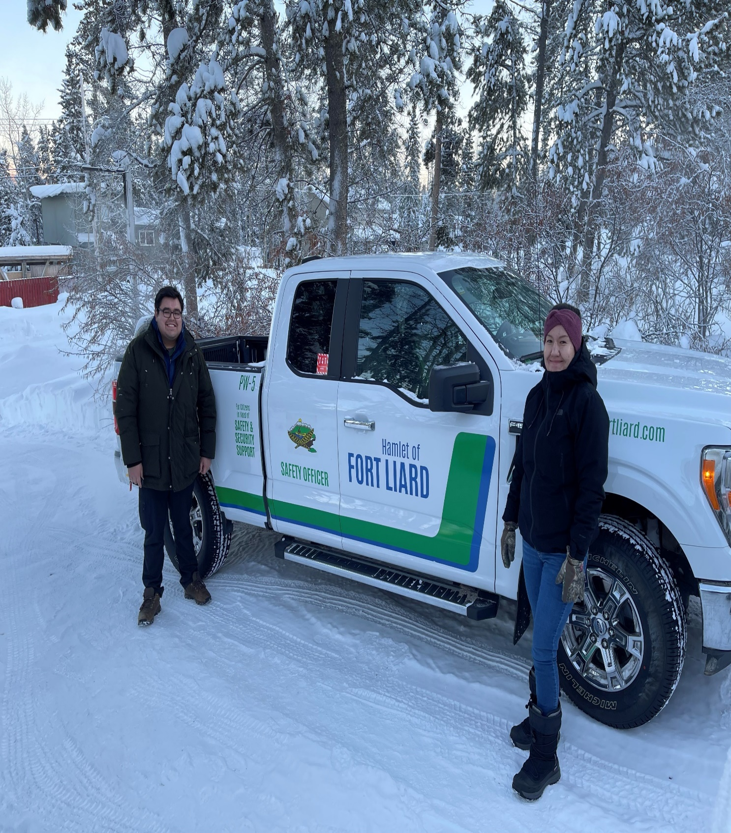
HAMLET OF FORT LIARD
COMMUNITY SAFETY DEPT.
YEAR END REPORT
2021

Councils Vision Statement ______________________________
“The Hamlet of Fort Liard is a progressive, healthy, and safe community that balances municipal services and programs to provide opportunities to the community while respecting the traditions and culture of its residents. We are leaders in fostering social integrity, economic development, and environmental sustainability.”

Councils Mission Statement_____________________________
“Council and staff of the Hamlet of Fort Liard are committed to sustaining our community’s culture while ensuring a strong future for all our citizens through quality leadership, accountable government, sound fiscal management, strong partnerships and delivery of the quality programs and services and by providing core infrastructure.”

TABLE OF CONTENTS__________________________________
COMMUNITY SAFETY INITIATIVES Pg.4
TRAINING Pg.6
PARTNERSHIPS
-FLVFD (FORT LIARD VOLUNTEER FIRE DEPT.) Pg.7
-RCMP Pg.9
WORKING WITH ELDERS (NWT SENIORS SOCIETY) Pg.12
FIRST YEAR STATS Pg.13
FINANCIAL STATEMENT Pg.14
FORMS AND REPORTS Pg.15

SAFETY INITIATIVES_________________________Pg.4
During the first year of “The Pilot Project”, we were faced with many growing pains during the development of the program.
But early on we had identified elder safety a high priority due to the lack of communication, which is mostly caused by a language barrier between English and South Slavey (Dene Yatie), which caused a delay in the response of emergency or non-emergency service providers. Partially due to the community’s lack of knowledge on civic addresses as Fort Liard had only put physical house numbers up in 2020. Due to this circumstance, we created the ‘Elders Signage Program”. We hope to take major steps in the implementation of this program in late April.
This isn’t the only issue or safety initiative which we are working on, we are outlining more programs which relate to Road Safety, Water Safety, ATV, snowmobile and boat safety, Substance Abuse Safety, and Wildlife Safety. Which will be outlined in our strategic plan.
ELDERS SIGNAGE PROGRAM____________________________
This program is a simple numbering system for vulnerable Elders within our community, so that service providers can more easily identify Elders homes in emergency or non-emergency situations. The numbering sign consists of a yellow reflective sign with the wording “Fort Liard, Elder Safety” and a number between 1-36, this sign would be placed where it is easily visible by service providers. The numbering signs will also be paired with a double sided OK/HELP sign that will hang in a window visible from the road in case other means of communication are disrupted or unavailable.

Pg.5
This program’s goal is to better identify elders’ homes for service providers, to erase the confusion related to civic addresses and road names, to increase elders means of communication, to reduce crime such as elder abuse/financial abuse, and to promote elder safety. Elders’ homes will be given a number which service
providers can reference to a list and get valuable information on the residence, such as the civic address, household residents, contact information, and even any medical conditions or mobility issues.

The program will be rolled out by identifying thirty-six houses with vulnerable elders/residents through consultation with community members and service providers. After this consultation is done an information list containing details about the residents will be made. Service providers will use this information to aid them when responding to requests for help or emergencies. All information will be kept confidential and be used only by service providers for the purpose intended.
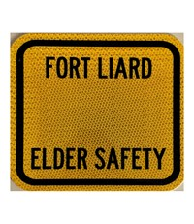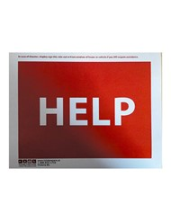

TRAINING_____________________________________Pg.6
Training is essential for the development of this program. Community Safety Officers were trained in a 10 day “Community Safety Officer Basic Training Program” through “Check Your Gear Solutions Consulting” in Whitehorse, YT. The program outlined areas of training which were essential to serving our community. Subjects which were taught included “Solution Orientated Situation Management; De-escalation; Non-violent Crisis Intervention; Dealing With Intoxicated People; Trauma Informed Care; Mental Health Awareness; Building Partnerships; Community and Cultural Awareness; Enhanced Observation Skills; and the fundamentals of Daily Operations.
First Aid is also very essential for the job we do.
Other training that may be essential to Community Safety Officers is, Wildlife Awareness due to the proximity almost all NWT communities are to wildlife.

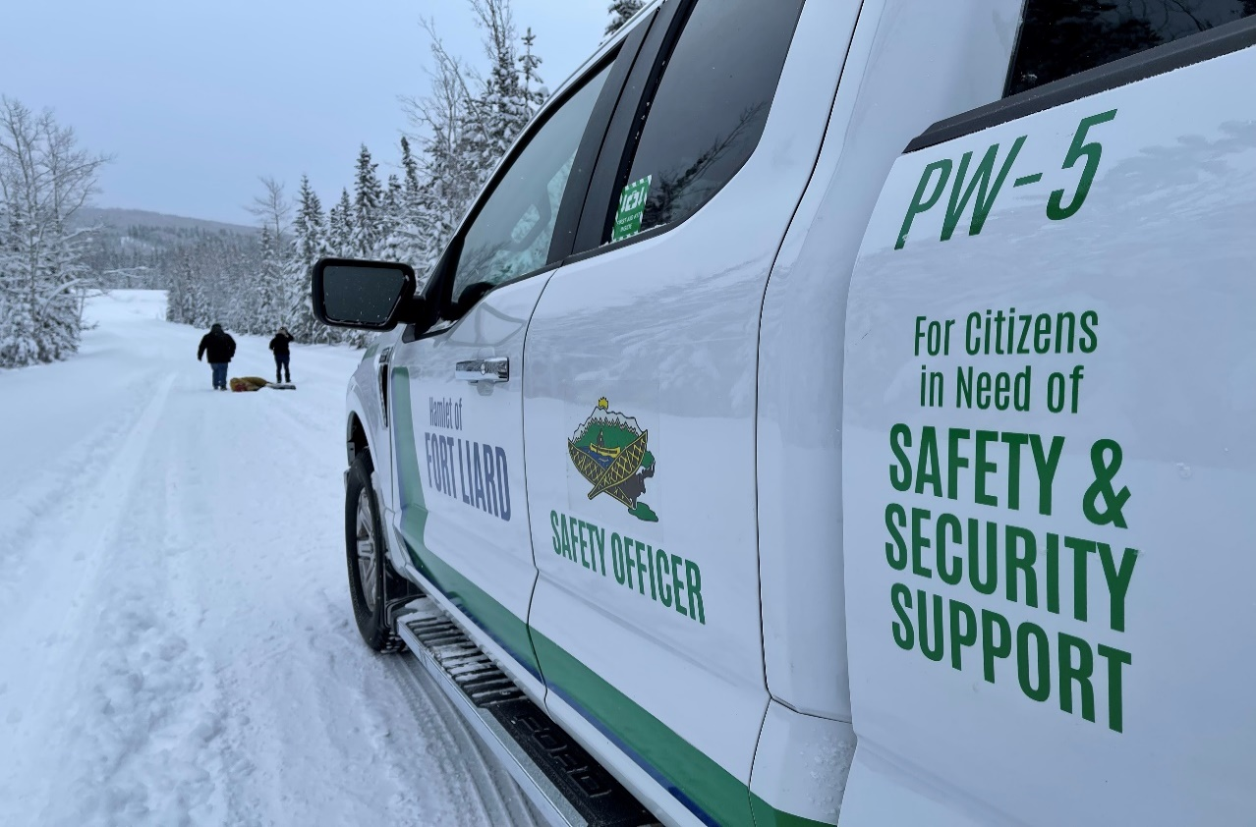
PARTNERSHIPS_______________________________Pg.7
One of the goals of the program was to have a community-based approach and partnerships to reduce crime. Over the first year of the program we have created partnerships with the Fort Liard Volunteer Fire Department, the RCMP, and Hamlet of Fort Liard Recreation.
FORT LIARD VOLUNTEER FIRE DEPARTMENT – FLVFD________
Through communication regarding fire safety, we have worked with the FLVFD to identify areas where we can help in emergency situations or fire calls. We have identified that it would be essential for us the conduct traffic/crowd control for emergency situations, also to provide First Aid when needed.
Community safety partnered with the “FLVFD” for Fire Prevention Week and had conducted a fire-drill at the school as well as a Fire escape plan contest, coloring contest and obstacle course. All activities were adjusted to promote fire-safety.
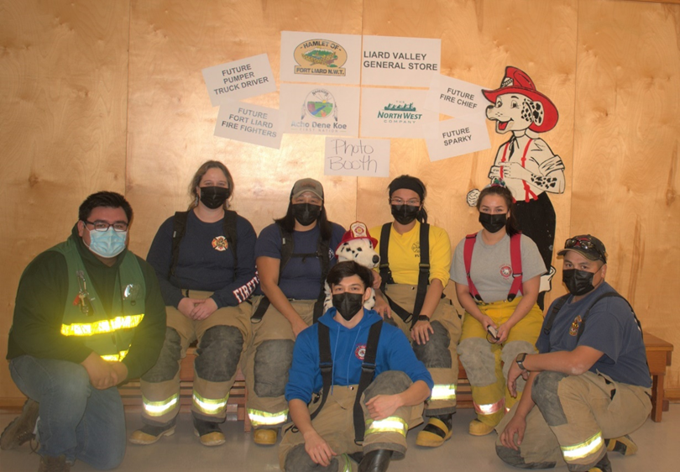

Community Safety and the FLVFD had also partnered for the Skate with Santa event at Hay Lake in December.

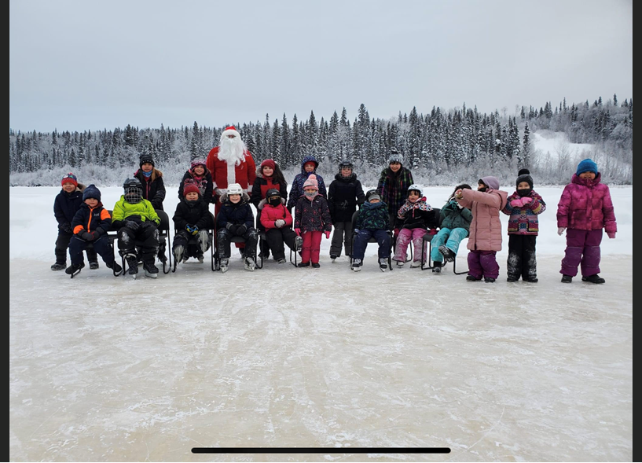

RCMP__________________________________________ Pg.9
FAMILY VIOLENCE PREVENTION MONTH -During the month of November, we partnered with the Fort Liard RCMP as well as the FLVFD to promote Family Violence Prevention Month. We did so by hosting a presentation with the high school students at Echo Dene School, we outlined what Family Violence was and how to prevent it, as well as asked and answered questions. We concluded the week with a walk to end Family Violence as well as sent children home with a package containing card games and healthy snack to promote a healthy activity to do with family.
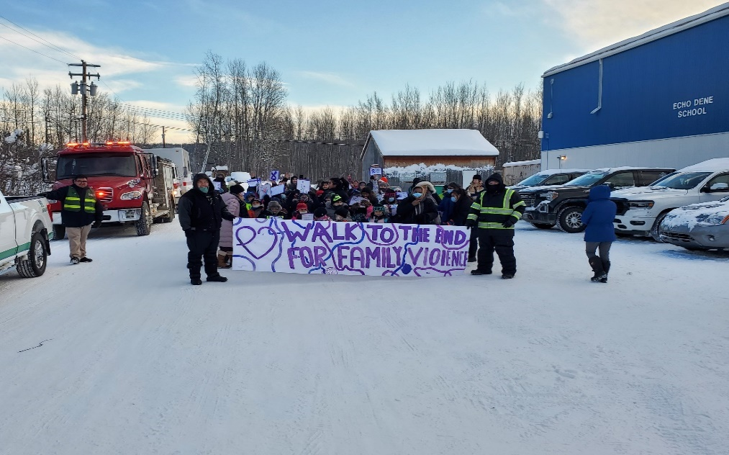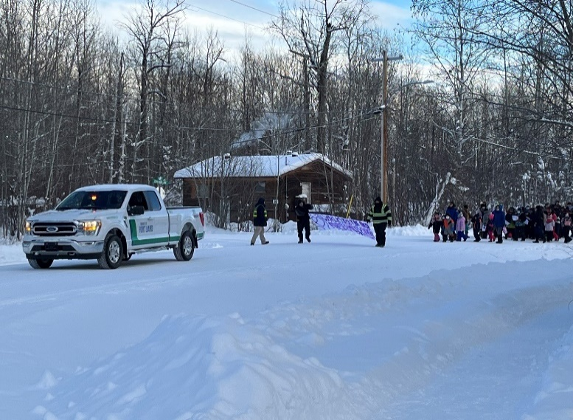
Pg.10
NATIONAL IMPAIRED DRIVING PREVENTION WEEK – JOINT CHECKSTOP
During the month of March 2022, Community Safety participated in a joint community check-stop to share information regarding impaired driving. On March 26th Community Safety Officers and the RCMP worked closely to bring awareness and promote safety related to impaired driving as well as increase our visibility in the community. The RCMP worked by conducting their traffic stop, while Community Safety officers stepped in to promote safe driving as well as hand out a flyer to encourage road users to contact 911 if they observe suspected impaired drivers.
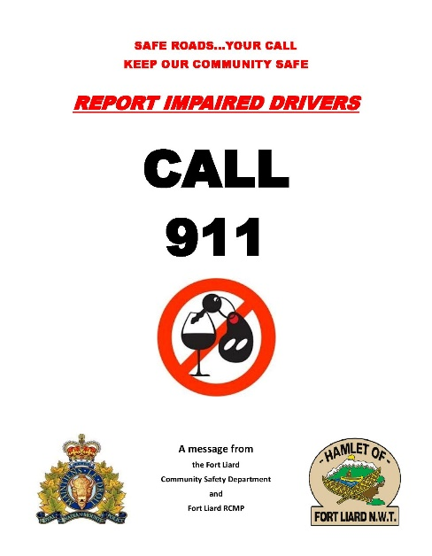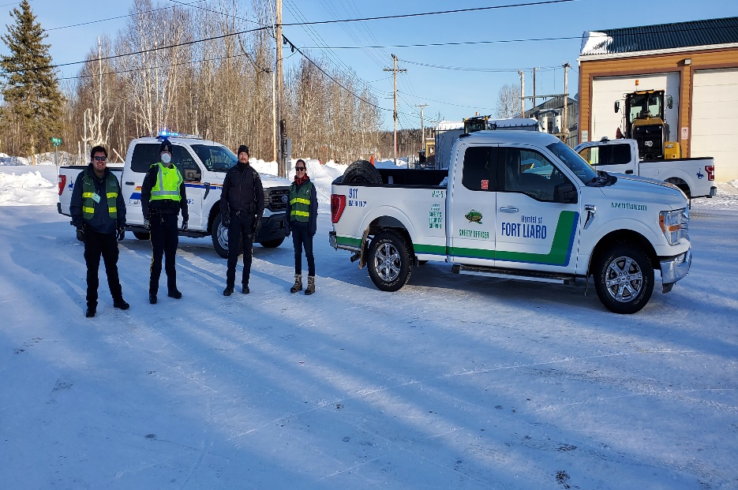

Pg.11
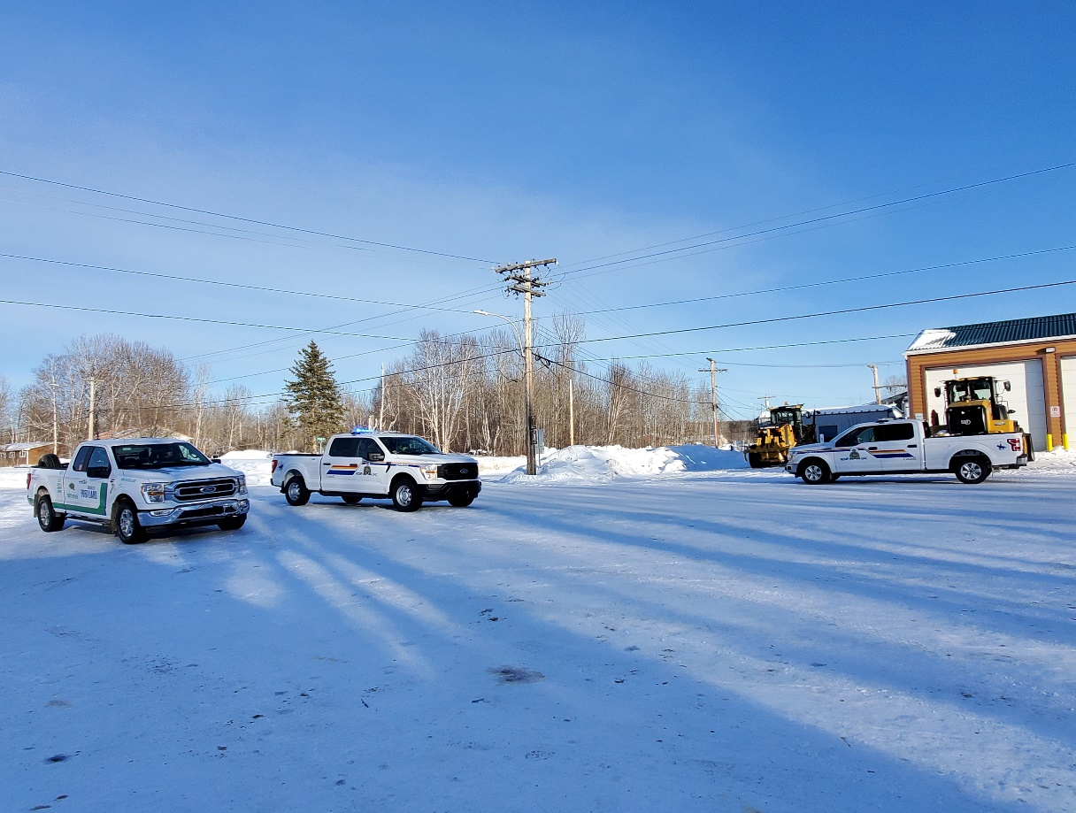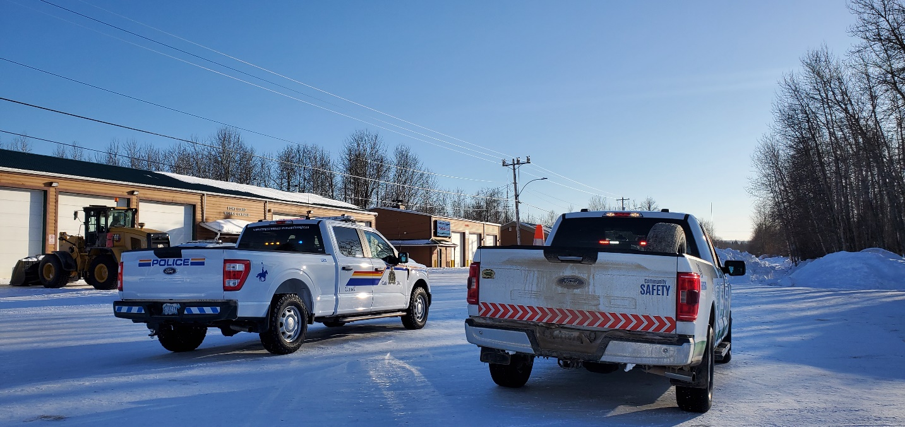

WORKING WITH ELDERS – NWT SENIORS SOCIETY_Pg.12
Community Safety Officers have also been working closely with the Hamlet’s Recreation Leader facilitating our Working with Elders’ Program. The goal of this program is.
To identify isolated, vulnerable older adults in 10 communities who have difficulty accessing services and meaningfully participating in their community.

To increase social connection of isolated, vulnerable, and other older adults through contact and social engagement.

To facilitate involvement of marginalized communities and increase community capacity to engage with at risk, isolated and other older adults.

To increase accessibility of information and knowledge in the Northwest Territories related to inclusive community planning practices, supports and services for older adults.

To influence future practices in community programming at the community and government level to be more inclusive and accessible for older adults who otherwise would be isolated from the community.

To support the Collective Impact approach by bringing together multi-sector collaborating HFL and NWTSS to achieve the common objective of increasing seniors’ social inclusion.
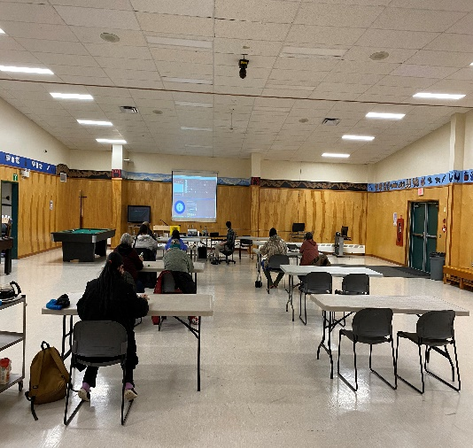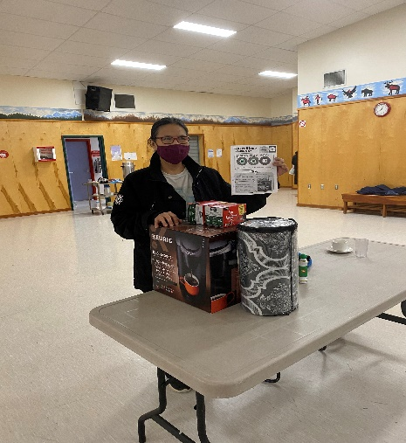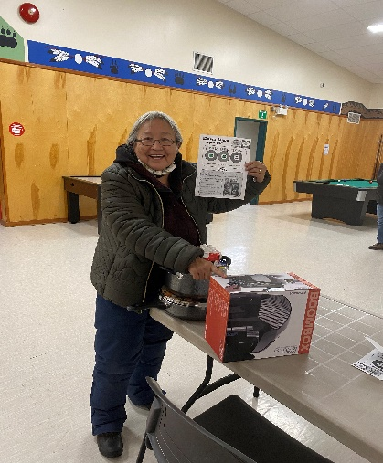
FIRST YEAR STATS Pg.13
During the first year of the “pilot” Community Safety Officers worked to create a reporting system which records all important details while protecting Community Safety Officers. The development of this reporting system took time, and all stats in this report may not include all incidents acted on. With the development of the “reporting system” we hope all stats for the 2022/2023 year to be accurate.
January was spent in training.
This table below reflects stats for the first year of the “pilot”.
Incident Type | SEPT. | OCT. | NOV. | DEC. | JAN. | FEB. | MAR. |  | YTD.
CALLS FOR SERVICE | 1 | 0 | 5 | 4 | 0 | 8 | 4 |  | 22
WELFARE CHECK/ASSIST PUBLIC | 7 | 4 | 5 | 7 | 0 | 7 | 1 |  | 31
NOISE COMPLAINT | 1 | 0 | 0 | 0 | 0 | 0 | 0 |  | 1
SAFE RIDES | 4 | 5 | 10 | 22 | 0 | 0 | 0 |  | 41
ELDERS RIDES/ASSISTANCE | 5 | 3 | 9 | 6 | 0 | 0 | 0 |  | 23
IMPAIRED DRIVER - REPORTED | 2 | 0 | 0 | 0 | 0 | 0 | 1 |  | 3
SAFETY INITIATIVES/COMMUNITY EVENTS | 1 | 1 | 3 | 0 | 0 | 0 | 1 |  | 6
EDUCATE on (speeding, ATV safety, littering, etc.) | 1 | 1 | 7 | 0 | 0 | 0 | 0 |  | 9
CONNECT RESIDENT WITH SERVICES | 0 | 1 | 0 | 0 | 0 | 0 | 0 |  | 1
CALLS TO RCMP | 2 | 1 | 2 | 0 | 0 | 0 | 2 |  | 6
MINOR PUBLIC DISTURBANCE | 0 | 0 | 0 | 0 | 0 | 0 | 1 |  | 1
VEHICLES STUCK | 0 | 0 | 0 | 0 | 0 | 0 | 2 |  | 2
STUCK ATV | 0 | 0 | 0 | 0 | 0 | 0 | 1 |  | 1
TRANSPORT TO HEALTH CENTRE | 0 | 0 | 0 | 1 | 0 | 1 | 1 |  | 3
INTOXICATED PERSON | 0 | 1 | 0 | 10 | 0 | 8 | 1 |  | 20
 |  |  |  |  | TOTAL NUMBER OF INCIDENTS RESPONDED TO. |  |  | 169

FINANCIAL STATEMENT Pg.14
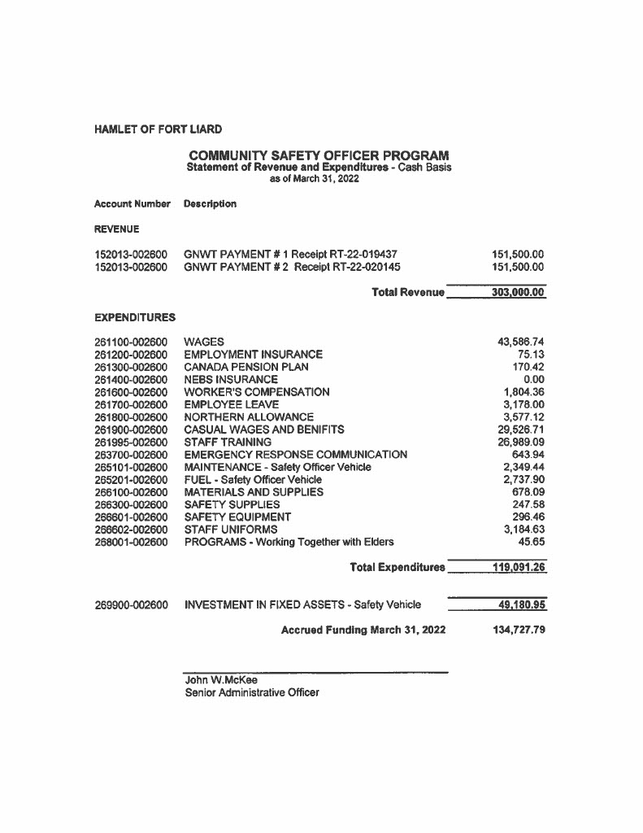
FORMS AND REPORTS Pg.15
The creation of forms and a reporting system was one of the more challenging aspects of developing this program. Below is the various forms and reports used for keeping track of shifts and incidents responded to.
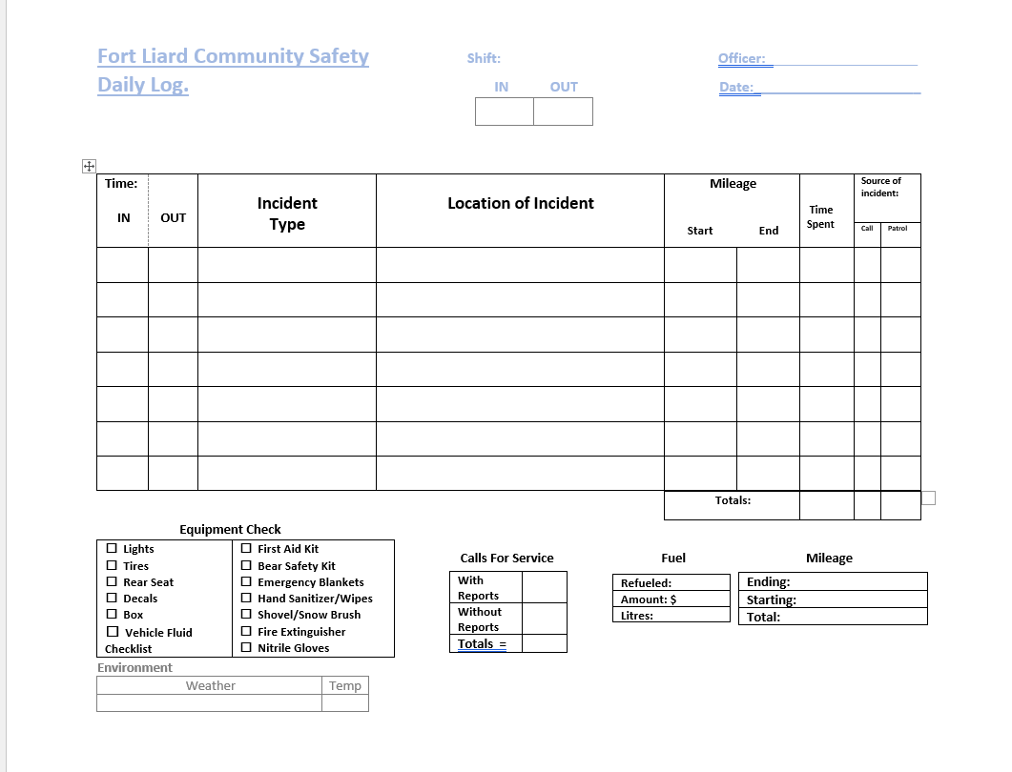

Pg. 16
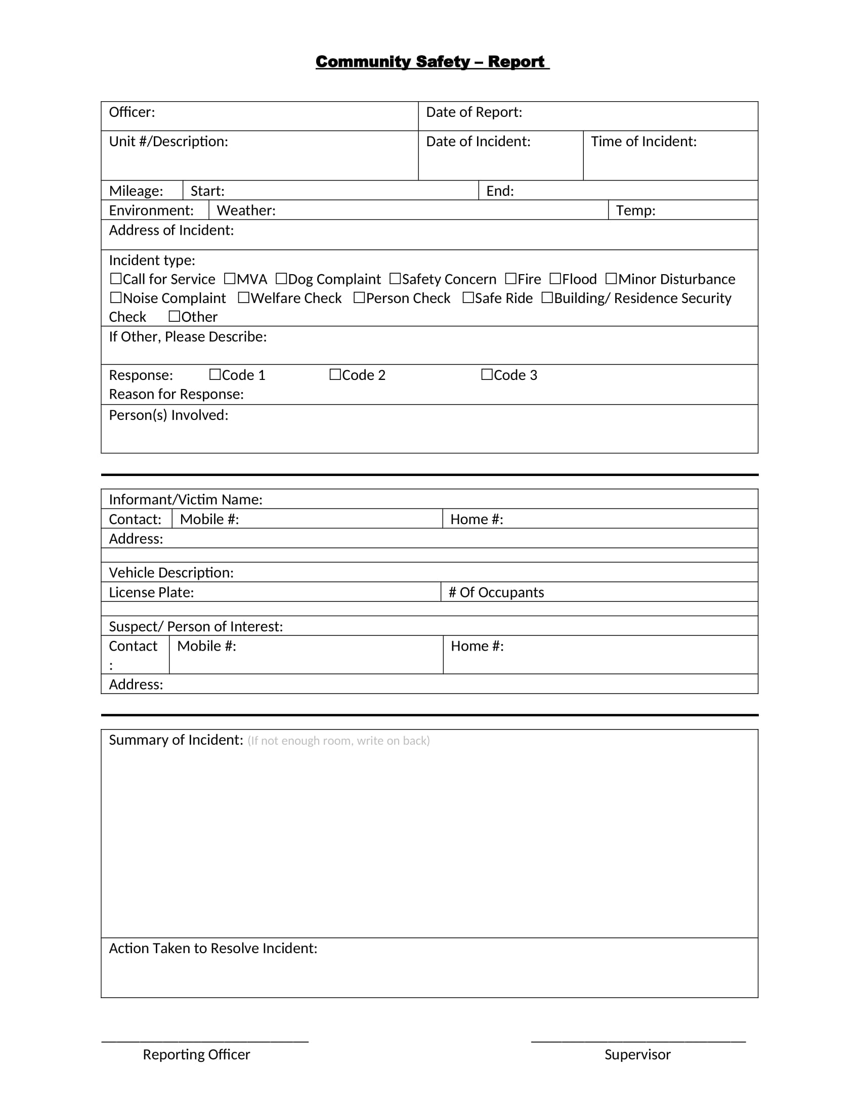
Pg. 17
