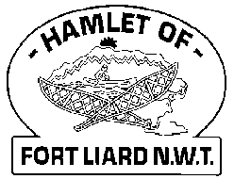
Fire Chief Monthly Report for December 2021

FTLVD, Recreation and ADKFN will be hosting a Christmas Parade Saturday, December 18, 2021. ADKFN have sponsored the prizes for the parade. The RCMP will be judging this event.
Skate with Santa at Hay Lake was a success. Thank you to our Community Safety Officers Dylan and Lindsay for providing Santa and the Fire Dept will be looking after everything else.
I would like to say a huge thank you to Fire Fighter Collin Woehl for his time and dedication to the Fort Liard Volunteer Fire Department. Best endeavours to you and your family in Hay River. Fort Liard’s loss but Hay River’s gain. Your presence will be missed at the Fire Hall.

Fire Practice: Every Wednesday evenings we meet at 6:30pm.
December 1st – Five in attendance, AFC Arthur Loe, Fire Fighters Kayly Deneron, Bailey Weber, Kali Norn and me, Fire Chief Evelyn Wilson. We drove out to Hay Lake to run the foam on the Pumper truck and then we drove to the Water Treatment plant to top off. When we got back to the Fire Hall, we reconnected the dry hose from the prior week and hung up the frozen hoses.
December 8th – Five (5) present, AFC Arthur Loe, Fire Fighters Kayly Deneron, Nathan Wilson, Ross Duntra and me, Fire Chief Evelyn Wilson. We went out to Hay Lake to help flood the area that was cleared for an outdoor rink but there was too much snow yet on top.
December 15th – Four (4) members present, AFC Arthur Loe, Fire Fighters Kayly Deneron, Nathan Wilson and me Fire Chief Evelyn Wilson. We went out to Hay Lake and cleared and flooded the rink for Skate with Santa.
December 22nd – NO FIRE PRACTICE
Skate with Santa at Hay Lake
Five of us present, AFC Arthur Loe, Fire Fighters Nathan Wilson, Ross Duntra, Kali Norn and me, Fire Chief Evelyn Wilson. An afternoon well spent at Hay Lake with Skate with Santa. We had such a great turn out with kids and adults especially with the warm weather.
December 29th – NO FIRE PRACTICE

Fires:
Issues / Concerns:
Going into Elder’s homes these last two weeks to see if their smoke detectors are working properly and majority of them don’t have any in their homes. The seven that we had on hand, were given out. Another six more homes need smoke detectors and 3 more need batteries. Its such an eye opener that some are without a smoke detector.
Five (5) Fire Fighters needed to replace their Bunker Gear jackets due to tears or oil residue on them. They are to be destroyed. Our PPE gear will need to be replaced soon.
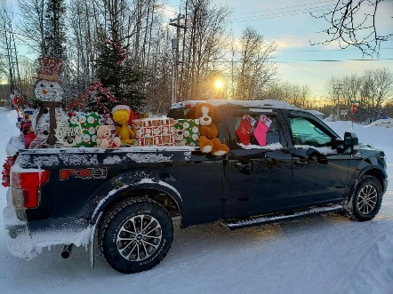
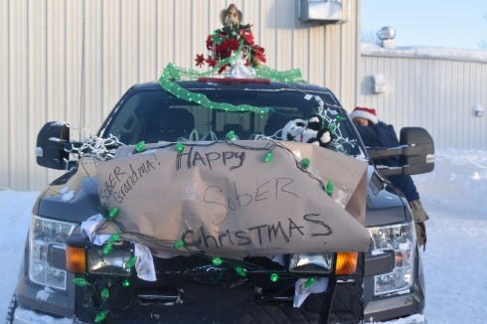

PERMITS
Fire Works Permits: Nine (9)
Burn Permits: NIL
Phone calls:
Fire Emergency –
Non-Emergency / Unknown Calls (No response) – NIL
Google Calls – One (1)

Active Members to Date:
Evelyn Wilson Arthur Loe Bailey Weber Ross Duntra
Nathan Wilson Kayly Deneron Ivy-Lynn Marcellais Kali Norn
Collin Woehl
