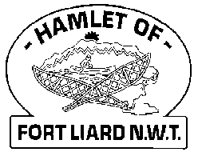

**Fire Chief Monthly Report for October 2020**

We started October off with our Fire Prevention Day activity, which was held Sunday, October 4, 2020 at the Skate Park. The events are as followed:

**2pm – 3pm** Coloring contest for ages 6 & under category plus the Obstacle Course

**3pm – 4pm** Home Fire Escape Plan for ages 7 to 10 plus an obstacle course

**4pm – 5pm** - Obstacle course for ages 11-14

*We broke up the event and time due to the Covid19 restrictions

We had a total of twelve (12) $25.00 gift cards donated from the Hamlet, the Northern Store, the General Store and ADK Band office. Each of the stores and offices got a Thank you poster with photos for their contribution toward this event. We also would like to thank Mayor Hillary Deneron and Constable Curtis Bowers for coming out to help to help with this event.

This event was such a great turn out, it is what our little community needed. Hearing such great / positive feedback from the parents, people in the community as well from the kids. After we packed up and tidied up everything from the Skate Park, we decided that we would all deliver the Gift cards to each of the individuals that won that day. Each of the kids felt so special because all the Fire Fighters came out to their homes to deliver their prize.

I personally want to say Thank you to AFC Arthur Loe, Fire Fighters Collin Woehl, Nathan Wilson, Kayly Deneron, Bailey Weber and Ivy Marcellais for your help

***Fires: NIL***

***Fire Practice:*** Every Wednesday evenings we meet at 6:30pm.

**October 7, 2020** – I cancelled practice that evening because of the event we held Sunday, Oct 4, 2020

**October 14, 2020** – Six of us present; AFC Arthur Loe, Nathan Wilson, Collin Woehl, Kayly Deneron, Ross Duntra and me. Our initial plan was to do a Fire Drill at the 9-Plex but the Caretaker was away, so we just tidied up and went for a drive through town.

**October 21, 2020** – Seven of us in total; AFC Arthur Loe, Collin Woehl, Ross Duntra, Nathan Wilson, Kayly Deneron, Ivy Marcellais and me. I got in contact with Ellen at Housing to see if we can do a practice fire drill at Senior’s 9-Plex. She had placed escape plans at each of the exits. We did a walk through, got on idea of the lay out of the building. After we were about to leave, we decided to go back in and practice carrying someone (Collin) out on a wheelchair through the one side door as there are no ramps at those exits. Gave us an idea what to expect if we really needed to carry someone out on a wheelchair. After we were done, we did a drove through town.

**October 28, 2020** – I wanted to show my appreciation to the Fire Fighters and their families. We planned a little get together inside the Hall. All eight of us were present that evening with our families.

***Active Members to Date:***

Evelyn Wilson Collin Woehl Arthur Loe Ross Duntra

Nathan Wilson Kayly Deneron Bailey Weber Ivy-Lynn Marcellais

***Issues:*** NIL

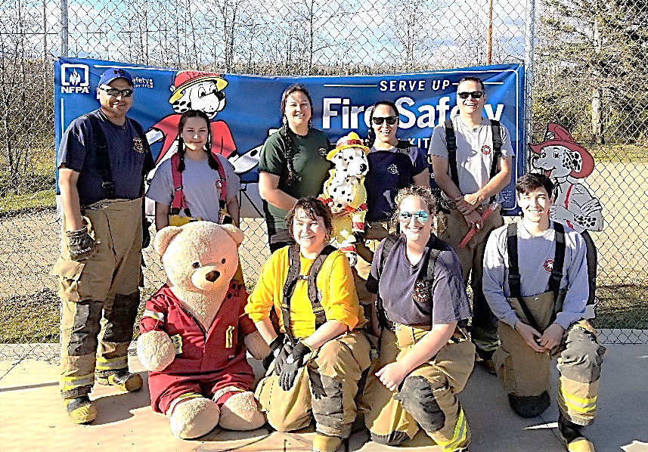***Phone calls:***

**Fire Emergency** – 0

**Google** – 7

**Unknown (no answer)** – 8

