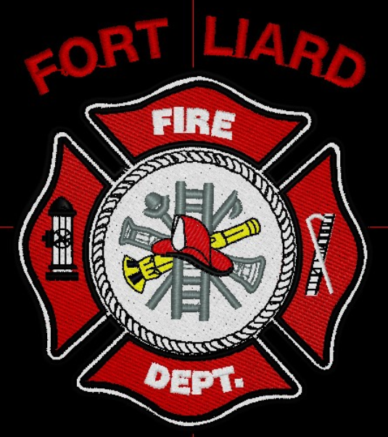
Current me mbers

Fire Chief – C. Evelyn Wilson
Start date: June 11, 2018

Assistant Fire Chief – Arthur Loe
Start date: April 1, 2012

Fire Fighters

Ivy-Lynn Marcellais
Start date: October 18, 2018

Kayly Deneron
Start date: November 1, 2018

Nathan Wilson
Start date: November 18, 2018

Ross Duntra (Gahcho Kué Mine) *will attend when in town
Start date: August 19, 2020

Kali Norn
Start date: March 5, 2021

Travis Goodburn (Rookie)
Start date: May 11, 2022

Lyle Bertrand (Rookie)
Start date: July 13, 2022

Cedar Wechlin (Rookie)
Start date: July 13, 2022
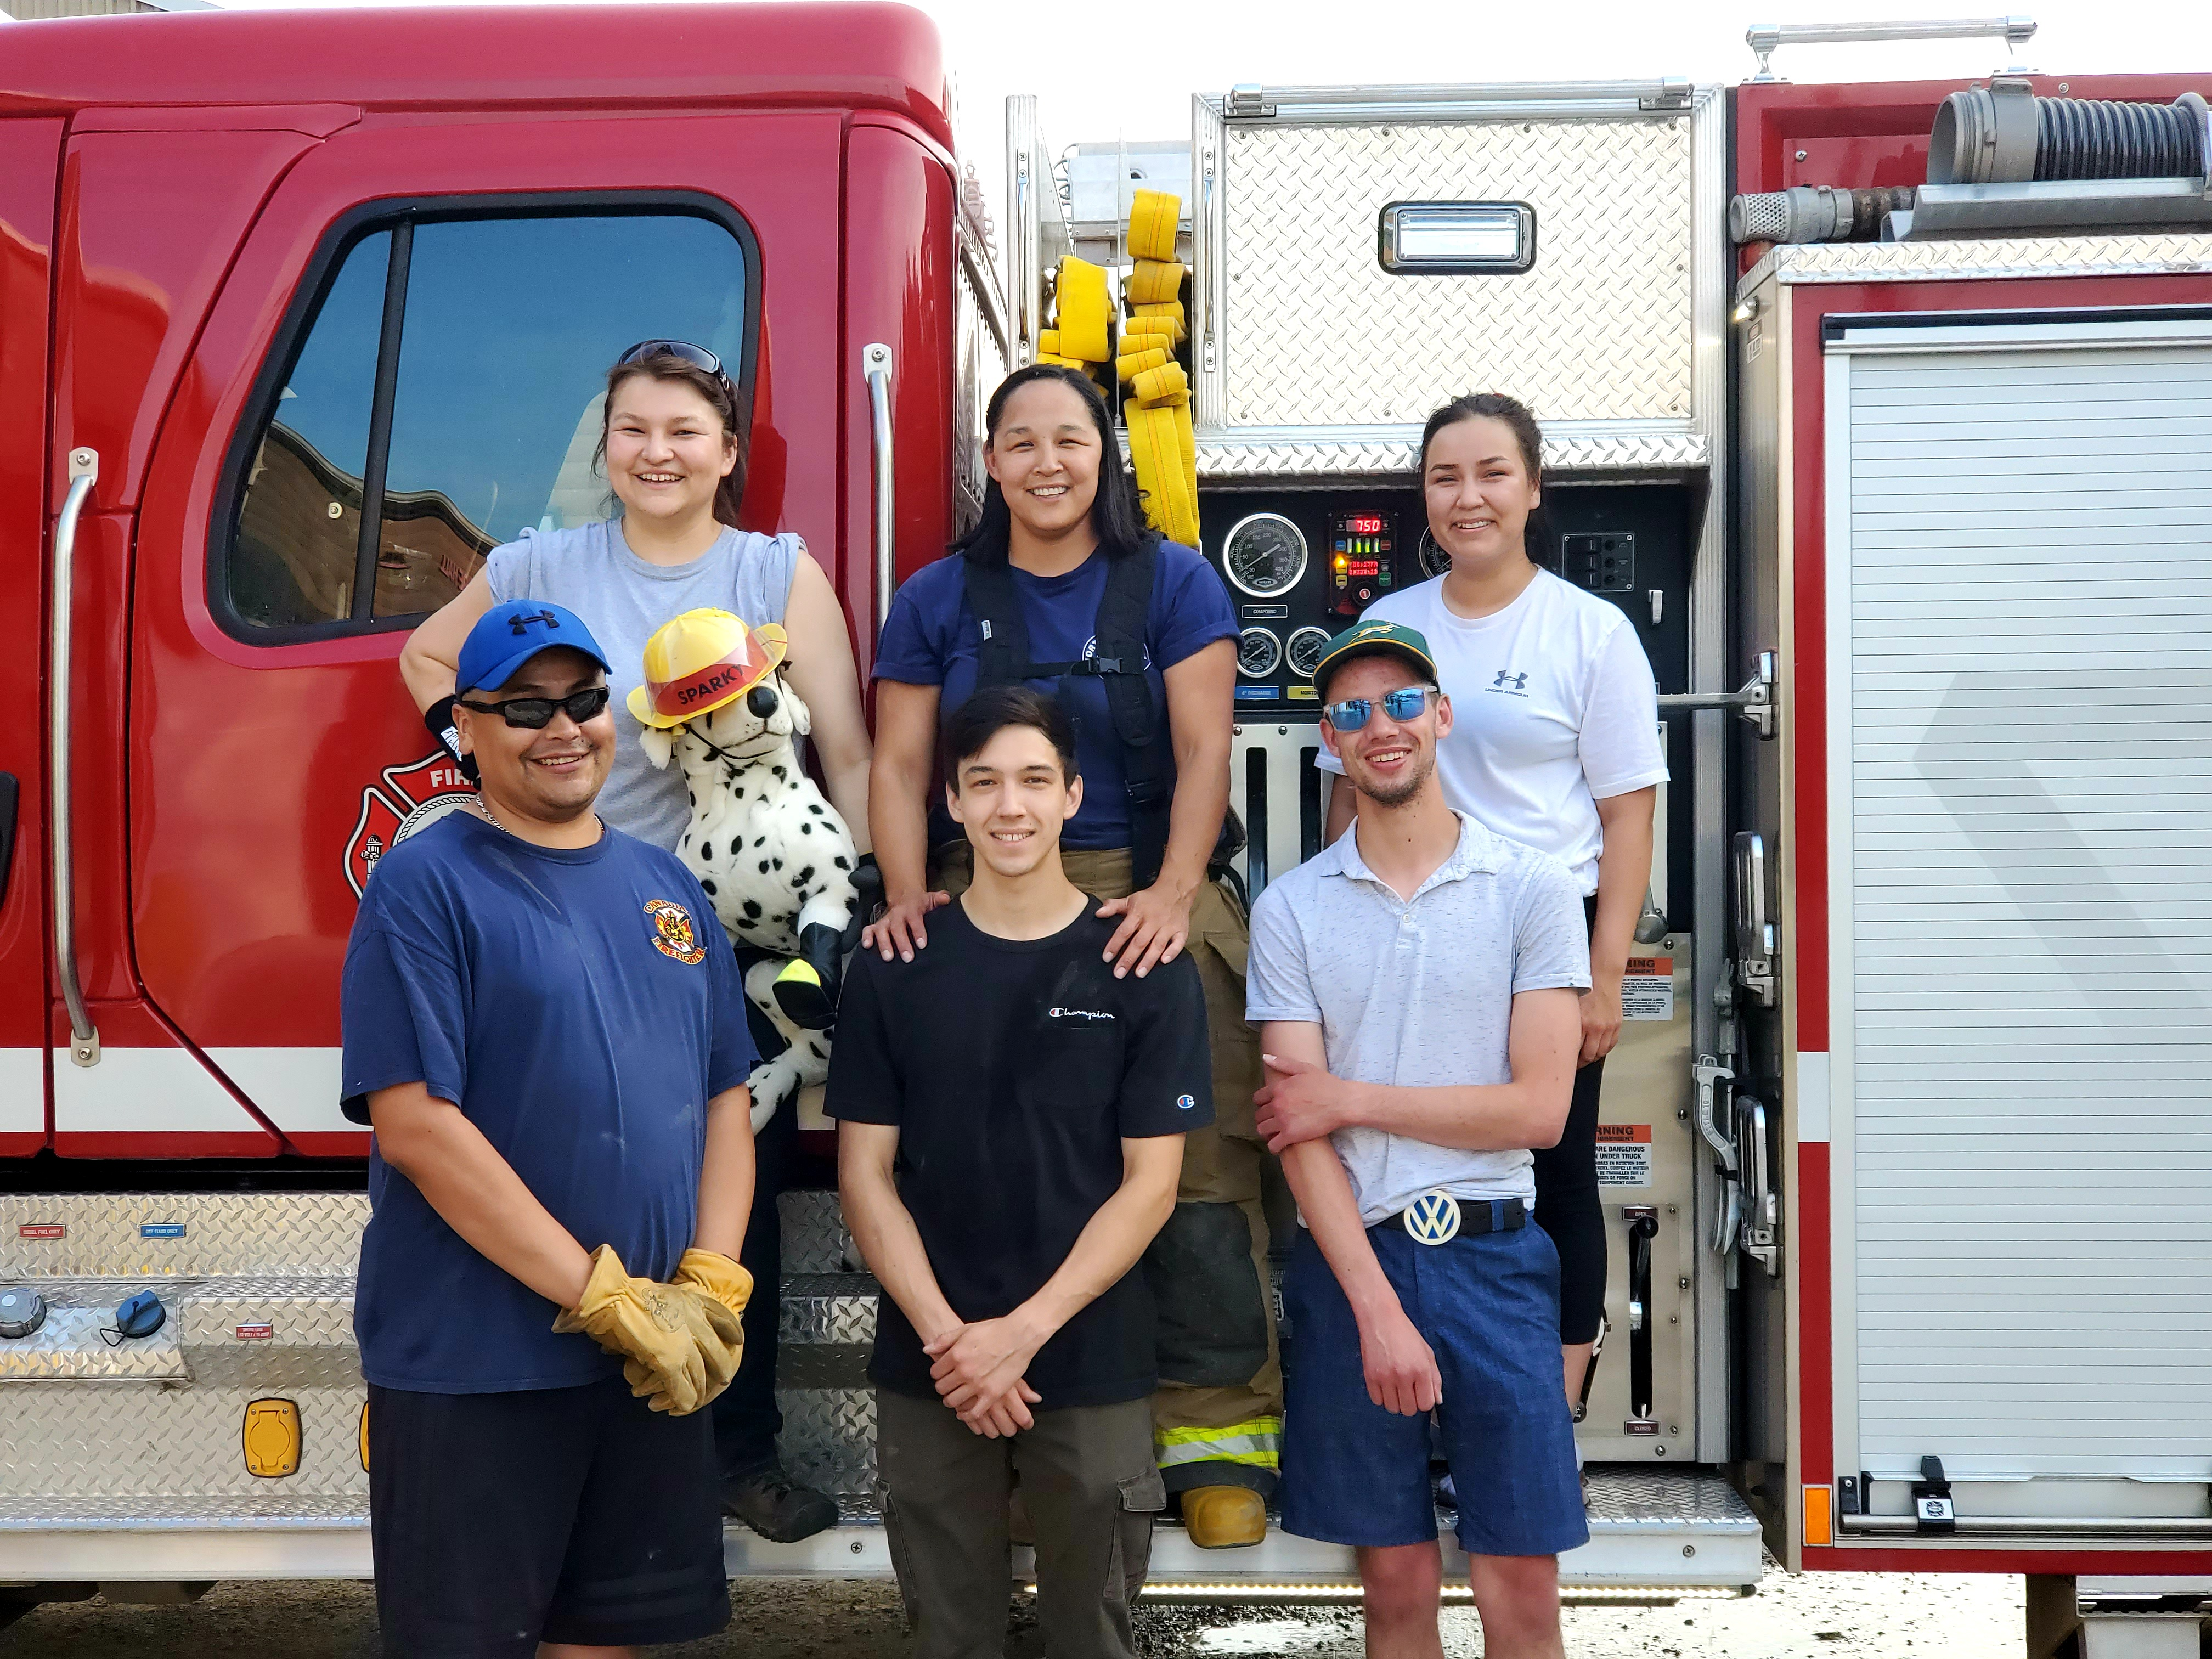
  - AUGUST 2022

fire chief’s report

Assistant Fire Chief Loe and along with Fire Fighter Wilson have been on call for most of August while I was away on annual. August has been a quiet month. Attendance was very low for the month of August as people were on summer break or busy with work.

ISSUES / CONCERNS:
Five (5) Fire Fighters need to replace their Bunker Gear jackets due to tears or oil residue on them. They are to be destroyed. Our PPE gear will need to be replaced soon.

Fire Practice – every Wednesday’s at 6:30pm

August 3rd, 2022
No one showed up for Fire Practice

August 10th, 2022
Four of us at practice, AFC Loe, Fire Fighters Goodburn and Bertrand and me, Fire Chief Wilson. We took the pumper truck to Hay Lake and ran our foam, went to top off the water then went for a ride through town. After they left, I took the Water truck out for a ride through town and back to the Fire Hall.

August 17th, 2022
Two present – Fire Fighter’s Wilson and Goodburn.

August 24th, 2022
AFC Loe was the only one present.

August 31st, 2022
Three in attendance, AFC Loe, Fire Fighters Deneron and Marcellais.

PERMITS: | CALLS RECEIVED:
Burn Permits: nil  Fire Works Permit: nil | Fire Emergency: nil  Non-Emergency: nil

