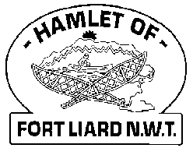
Fire Chief Monthly Report for November 2021

Fort Liard Volunteer Fire Dept will be working along with the RCMP Detachment with the Family Violence Prevention Program. We had put together Family Movie / Game night packages together with included granola bars, rice crispy square, fruit snacks, cookies, popcorn, and juice boxes. 56 family packages were delivered to the school and four were sent to Nahanni.
We have a draw to win one of four (4) $50.00 gift cards donated by the General Store and Northern Store for those who submit photos from their Family Movie / Game night. We had a total of five entries, all five families received a gift card.
We held a small get together for Collin and his boys November 24 as they will be leaving for Hay River end of December. Thank you, Collin, for your hard work and services with the Fort Liard Volunteer Fire Department.

Fire Practice: Every Wednesday evenings we meet at 6:30pm.
November 3rd – Six (6) present, AFC Arthur Loe, Fire Fighters Kayly Deneron, Ivy-Lynn Marcellais, Kali Norn, Ross Duntra and me, Fire Chief Evelyn Wilson. We finished up the Smoke Detector checks in the elder’s home downtown.
November 10th – Five of us in attendance AFC Arthur Loe. Fire Fighters Ivy Marcellais, Ross Duntra, Kali Norn and me Fire Chief Evelyn Wilson. We shuffled everyone around on truck, AFC Loe and FF Duntra on Water Truck, FF Marcellais and Weber on Support and will continue FF Wilson, Deneron and Norn on Pumper truck.
November 17th – Six (6) present – AFC Arthur Loe, Fire Fighters Kayly Deneron, Ivy-Lynn Marcellais, Ross Duntra, Kali Norn and me, Fire Chief Evelyn Wilson. This evening we did some ladder training at the Community Hall and the Library.
November 24th – Eight (8) of us in attendance – AFC Arthur Loe, Fire Fighters Collin Woehl, Nathan Wilson, Ivy-Lynn Marcellais, Bailey Weber, Ross Duntra and Kali Norn and me, Fire Chief Evelyn Wilson. We had a going away dinner last night at the Fire Hall for Collin and his boys.

Fires:
Issues / Concerns:
Going into Elder’s homes these last two weeks to see if their smoke detectors are working properly and majority of them don’t have any in their homes. The seven that we had on hand, were given out. Another six more homes need smoke detectors and 3 more need batteries. Its such an eye opener that some are without a smoke detector.
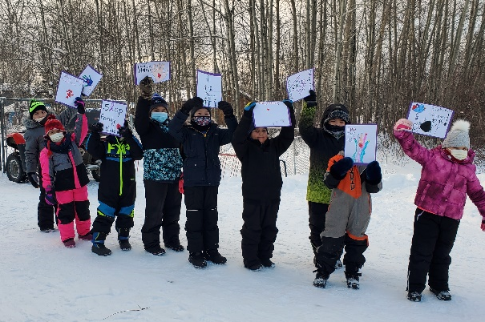
Five (5) Fire Fighters needed to replace their Bunker Gear jackets due to tears or oil residue on them. They are to be destroyed. Our PPE gear will need to be replaced soon.

PERMITS
Fire Works Permits:
Burn Permits: NIL

Phone calls:
Fire Emergency – One (1)
Non-Emergency / Unknown Calls (No response) – one (1) call
Google Calls – Seven (7)
Active Members to Date:
Evelyn Wilson Collin Woehl Arthur Loe Bailey Weber
Nathan Wilson Kayly Deneron Ivy-Lynn Marcellais Kali Norn
Ross Duntra

