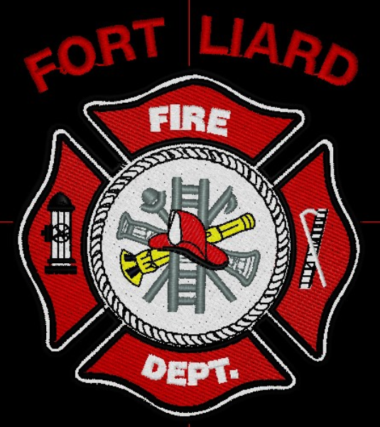
Current me mbers

Fire Chief – C. Evelyn Wilson
Start date: June 11, 2018

Assistant Fire Chief – Arthur Loe
Start date: April 1, 2012

Fire Fighters

Ivy-Lynn Marcellais
Start date: October 18, 2018

Kayly Deneron
Start date: November 1, 2018

Nathan Wilson
Start date: November 18, 2018

Ross Duntra (Gahcho Kué Mine) *will attend when in town
Start date: August 19, 2020

Kali Norn
Start date: March 5, 2021

Travis Goodburn
Start date: May 11, 2022
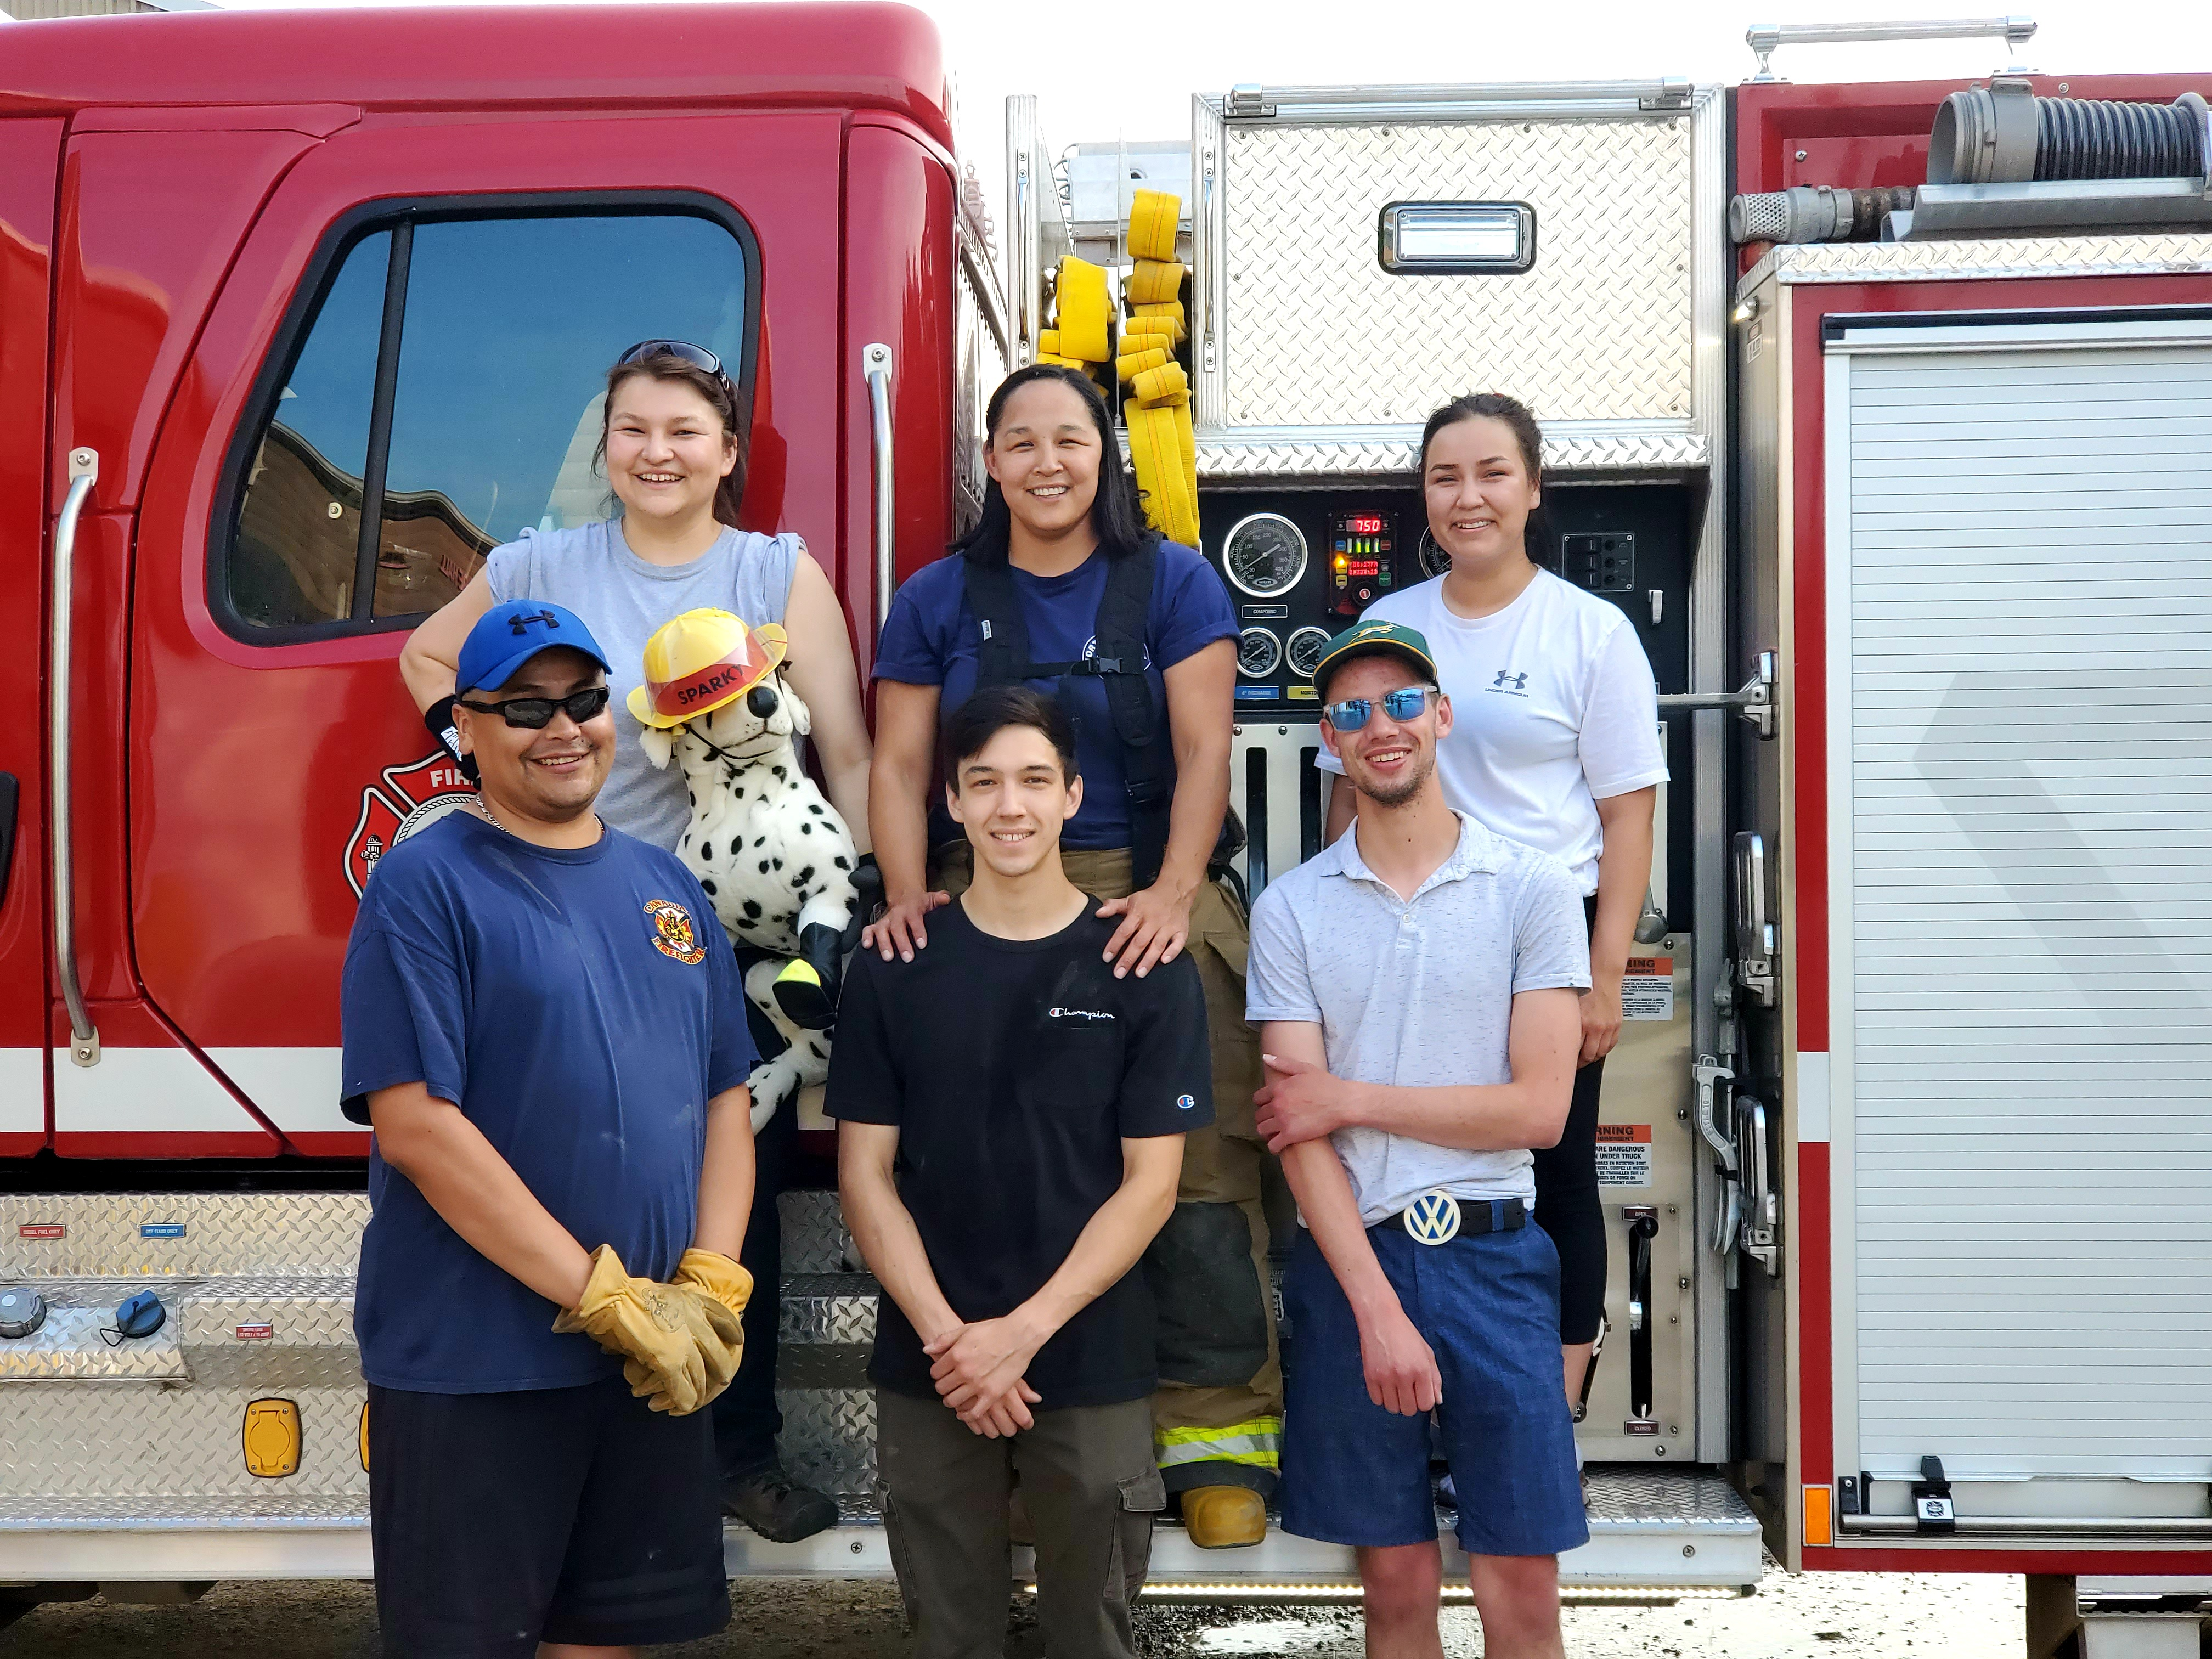
  - June 2022

fire chief’s report
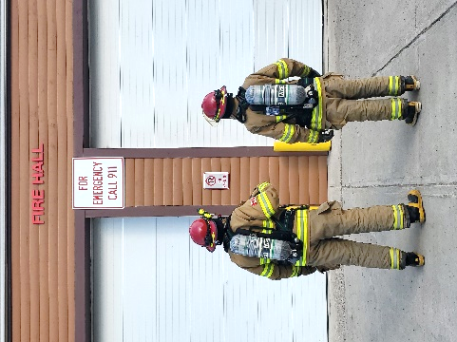
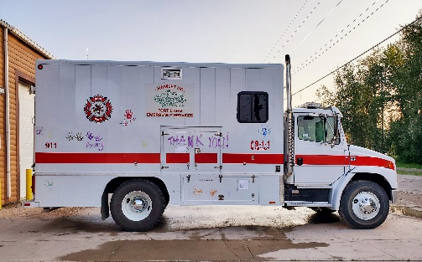
Shane Seaman, Assistant Fire Marshal for the DehCho Region came into the community June 29, 2022, to introduce himself. He met with John, afterward I gave him a tour of the Fire Hall and the community. He mentioned early September through October there will be a Basic Defensive Fire Fighting Course.
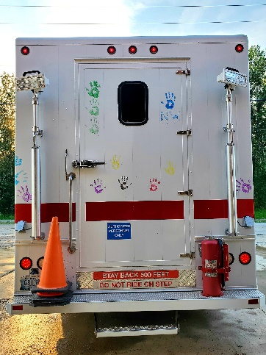
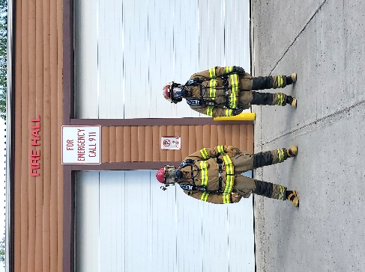

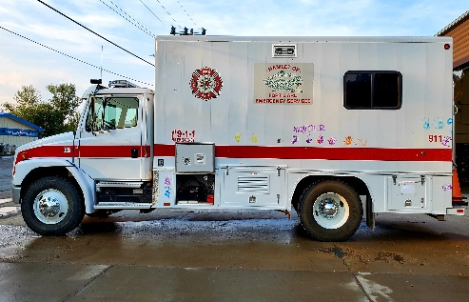

ISSUES / CONCERNS:
Five (5) Fire Fighters need to replace their Bunker Gear jackets due to tears or oil residue on them. They are to be destroyed. Our PPE gear will need to be replaced soon.

Fire Practice – every Wednesday’s at 6:30pm
June 1st, 2022
Four in attendance – AFC Loe, Fire Fighters Wilson & Marcellais and me, Fire Chief Wilson. We unpacked the new MSA SCBA’s and both Arthur and Nathan tested them out. Pretty neat and high tech from our old SCBA’s.

June 8th, 2022
We had planned for a Fire Drill at the Echo Dene School before end of the school year. Assistant Fire Chief Loe, Fire Fighter Wilson and me, Fire Chief Wilson went to the school that afternoon and set the alarm off. They all exited the school in a timely manner. Well done!
This evening for practice there was three of us in total, AFC Loe, Fire Fighter Marcellais and me, Fire Chief Wilson. We went for a ride through the community with the Pumper truck and tidied up the Hall.

June 15th, 2022
Five members out this evening, AFC Loe, Fire Fighters Deneron, Marcellais, Norn and me, Fire Chief Wilson. We are planning to host an Open House June 29th, 2022, at 7:00pm hoping to draw in more volunteers to join the Fire Dept.

Donning and Doffing our Gear – This was a timed event. We then individually ran from the Northern Store stairs, entered in the side door of the Fire Hall, got on our Bunker gear, out the front door with our hands up for the timer to stop.
After we all completed this, we set up an obstacle course outside and each took part on the exercise.

June 22nd, 2022
Four of us ladies this evening, Fire Fighters Deneron, Marcellais, Norn and me, Fire Chief Wilson. This evening we washed the Pumper Truck inside the Bay and cleaned out Bay one. We’re planning on hosting an Open House, June 29, 2022, hoping to get more recruits in board to join the Fire Dept.

June 29th, 2022
Six of us present, AFC Loe, Fire Fighters Marcellais, Deneron, Wilson, Goodburn and me Fire Chief Wilson. This evening we held an Open House hoping to recruit new members. We had stew/ Bannock and hot dogs for the kids. We set up an obstacle course for the youth and afterward painted their handprints on the Support truck for Canada Day. Four people have picked up applications with two possible new recruits. One filled out during the Open House and the other waiting on supervisor approval.
PERMITS: | CALLS RECEIVED:
Burn Permits: NIL  Fire Works Permit: NIL | Fire Emergency: One (1) RCMP called about missing person reported, forwarded them onto Community Safety Officer  Non-Emergency: Three (3)

