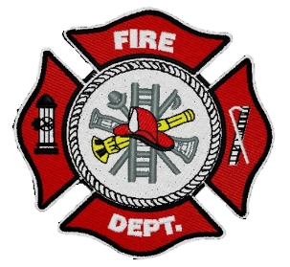
FORT LIARD

Current me mbers

Fire Chief
C. Evelyn Wilson
Start date: June 11, 2018

Assistant Fire Chief
Kayly Deneron
Start date: November 1, 2018

Fire Fighters

Captain – Nathan Wilson
Start date: November 18, 2018

Arthur Loe
Start date: April 1, 2012

Ivy-Lynn Marcellais
Start date: October 18, 2018

Seymore Chambers
Start date: September 7, 2022

Ainsley Allen (Rookie)
Start date: January 18, 2023

Jade Ajibade (Rookie)
Start date: January 25, 2023

Stevenson Klondike (Rookie)
Start date: April 5, 2023

Precious Timbre-Hope (Rookie)
April 26, 2023

  - APRIL 2023

fire chief’s report

I had helped with planning the 2023 Cabin Fever Days Jail “n” Bail with the ladies from the Band office, it was a success.
April 9, 2023 – Cabin Fever Days Pancake Breakfast. The FTLVFD and Fort Liard RCMP Detachment partnered up together and hosted the 2023 Cabin Fever Days Pancake Breakfast, this was held at the Community Hall. Assistant Fire Chief Kayly Deneron, Fire Fighters Ivy-Lynn Marcellais, Ainsley Allen and me, Fire Chief Evelyn Wilson along with RCMP members Corporal James Charles, Cst. Sam Sweazy and their wives were all in attendance at this event. Such a great turnout. Thank you for allowing us to use the Community Hall kitchen.
April 12, 2023 - CHR Rep – Marlene Timbre along with Registered Nurse Darcey Fownes asked to see if they’re able to host a Naloxone Info Session with the Fire Dept along with community members who wanted to take part. There were six Fire Fighters along with six others from the community present for this. Thank you to Marlene and Darcey for sharing the information session.
April 27, 2023 - The Grade 1, 2 & 3 teacher Ms. Quinn and students from Echo Dene School came to get a Fire Hall tour. AFC Deneron and Fire Fighter Wilson were in attendance.
Working with the different organizations helps build good community relationships and working together makes a difference.
We would also like to welcome Stevenson Klondike and Precious Timbre-Hope who are our newest Recruits/ Rookies to the FTLVFD. We currently have five ladies and five guys.
This month together we put in a total of 137hrs with Fire Practice and community events.
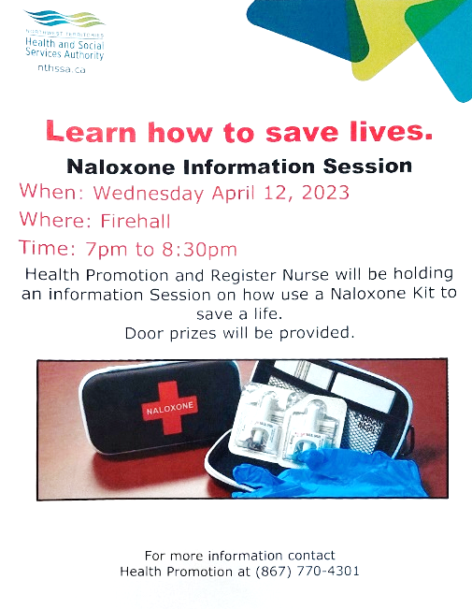
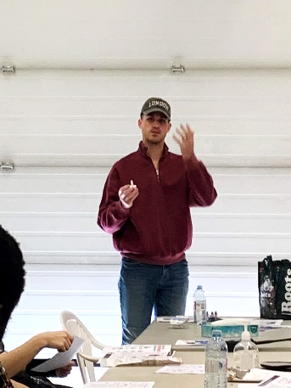

Fire Practice – every Wednesday’s at 6:30pm
April 5, 2023
Five in attendance, AFC Deneron, Fire Fighters Chambers, Allen, Klondike and me, Fire Chief Wilson. Assistant SAO Robert Firth came by, and we assisted him with the Inventory for the Fire Dept. After we were done that, we gave our newest recruit Rookie Klondike a tour of the Fire Dept. As we were

April 12, 2023
Six members were present, AFC Deneron, Fire Fighters Wilson, Chambers, Allen, Ajibade and me, Fire Chief Wilson. This evening we had the Naloxone Workshop with Health & Social Services CHR Marlene Timbre and Registered Nurse Darcey Fownes.

April 19, 2023
Five of us, AFC Deneron, Fire Fighters Loe, Marcellais, Chambers and me, Fire Chief were present for Fire Practice. This evening ASAO Robert Firth came back to the hall to look at the SCBA Air compressor, after running it a couple times, it was noted that it needed to be repaired. Once it’s repaired, we will be sending out a couple SCBA Bottles for testing. After he left, we timed ourselves donning our PPE gear.

April 26, 2023
Eight members out this evening. Assistant Fire Chief Deneron, Fire Fighters Loe, Wilson, Marcellais, Chambers, Rookies Ajibade, Timbre-Hope and me, Fire Chief Wilson. We had FF Loe and Wilson head out to the Community Hall with their SCBA’s and we went to do a live search and rescue. Afterward, we went for a community drive and back to the hall.

PERMITS: | CALLS RECEIVED:
Burn Permits: One (1)  Fire Works Permit: | Fire Emergency: 1 (One), copy of the Fire Incident Report emailed off to AFM.  Non-Emergency: (2) Two
ISSUES / CONCERNS:
- All our PPE Gear are in need of replacement, due to oil residue and tears/rips.

- First Aid/ CPR, Chain Saw Course and Air Brakes

- Radios, everyone on the scene should have some sort of communication. They’ll be working in pairs for now but if they get separated for a reason, there will be do communication.

- Flashlights are highly recommended.

- Spare MSA/ SCBA bottles or an upgrade on the fill station at the Fire Hall.

